TABLE OF CONTENTS

1. ML Basics

2. FL Design Principle

3. Gradient Methods

4. FL Algorithms

5. FL Flavors

6. Graph Learning

7. Trustworthy AI

8. Privacy in AI

9. Data poisoning in FL

## 1. ML Basics

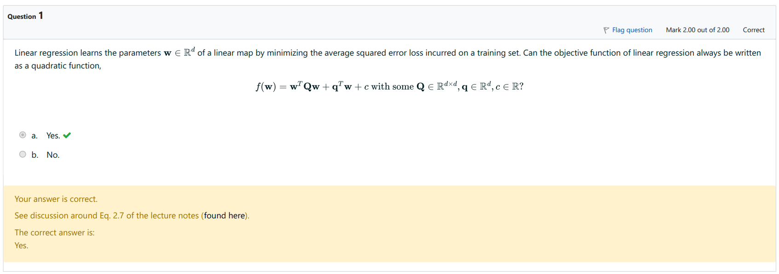

Lecture - "ML Basics", Three Components and a Design Principle (Equation 2.7)

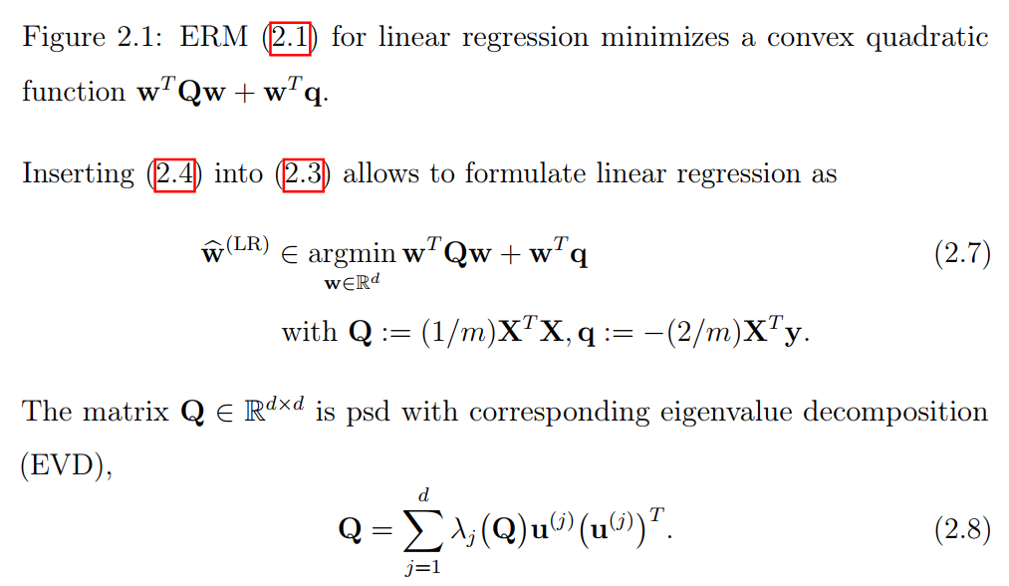

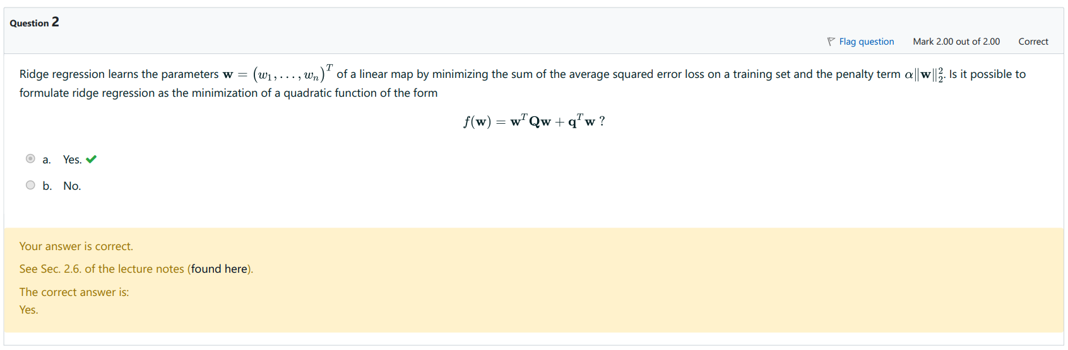

Lecture - "ML Basics", Regularization (Equation 2.27)



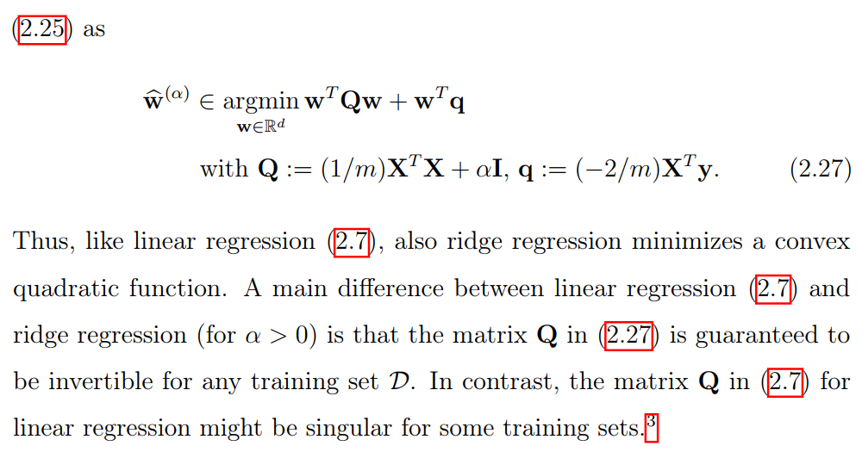

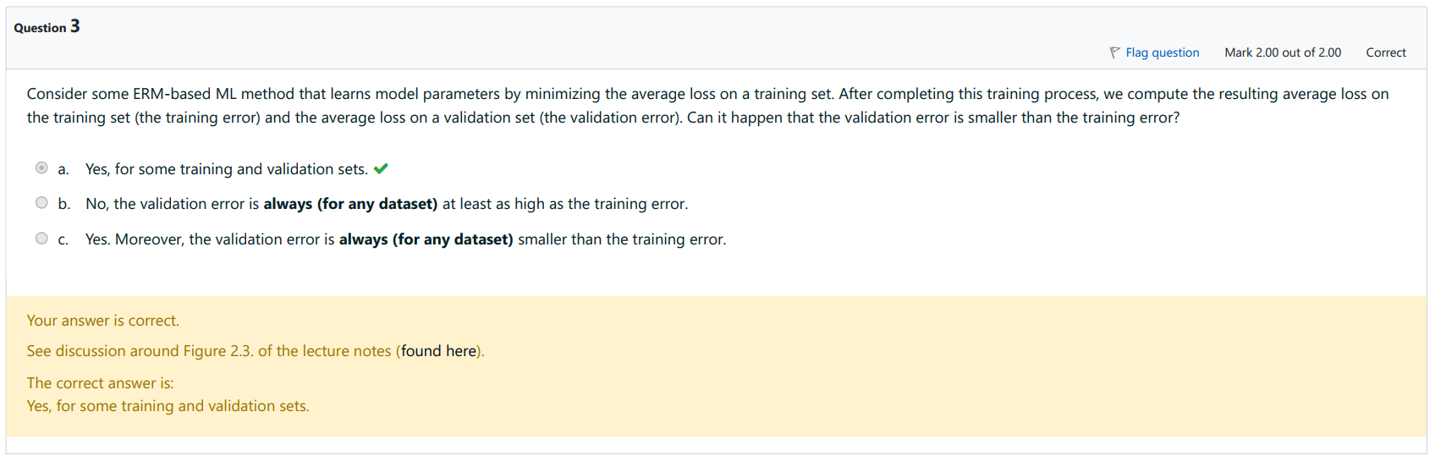

Lecture - "ML Basics", Validation and diagnosis of ML

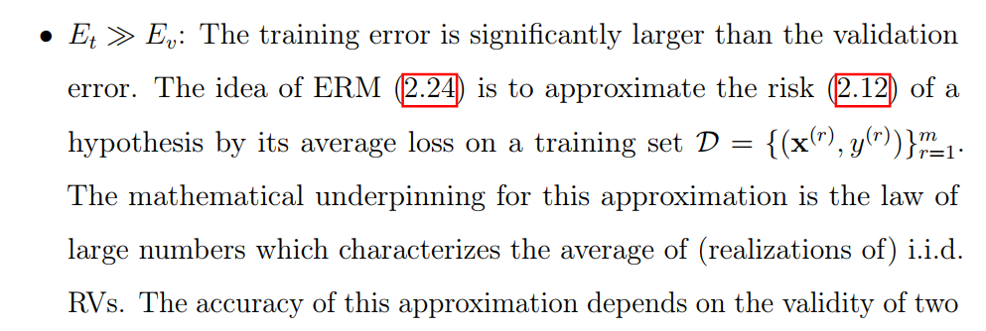

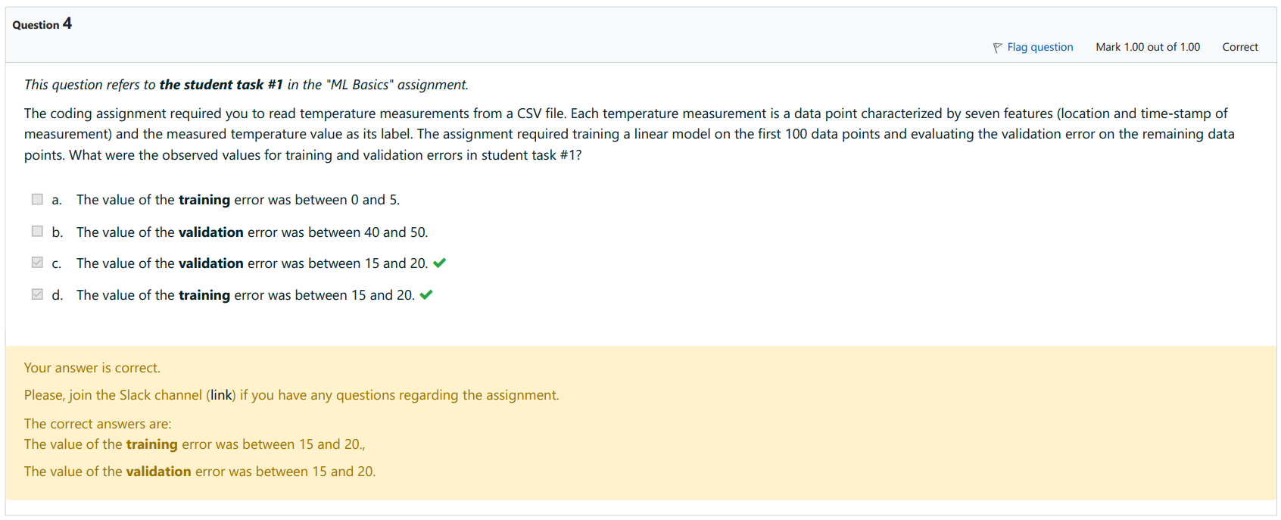

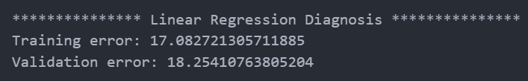

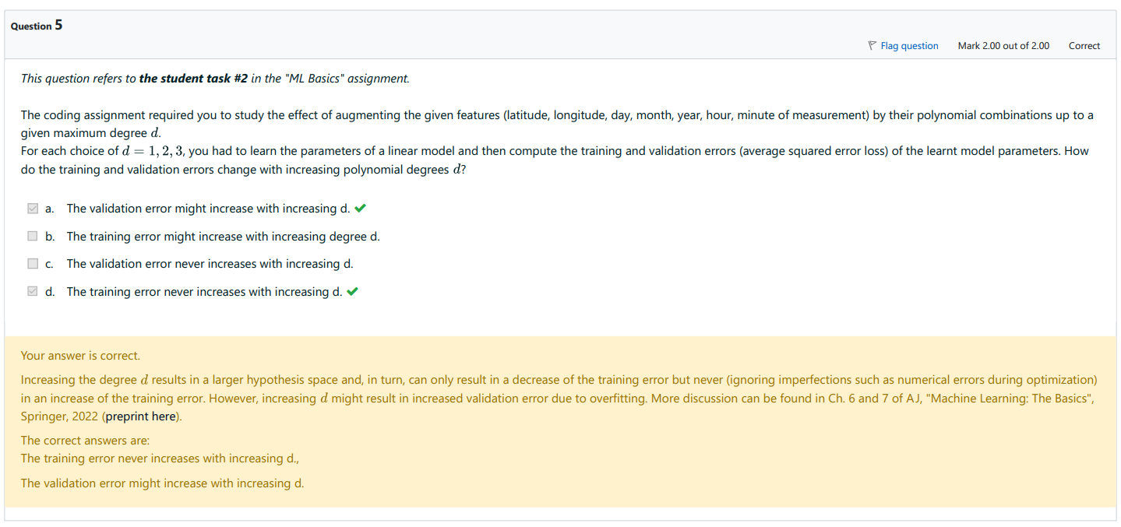

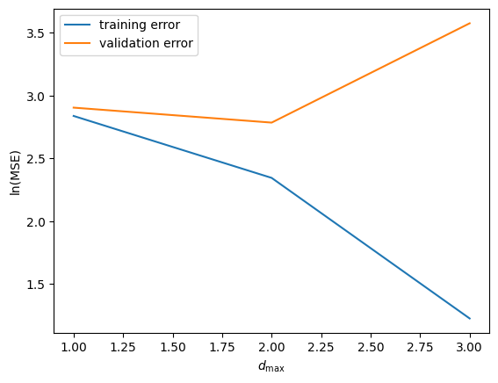

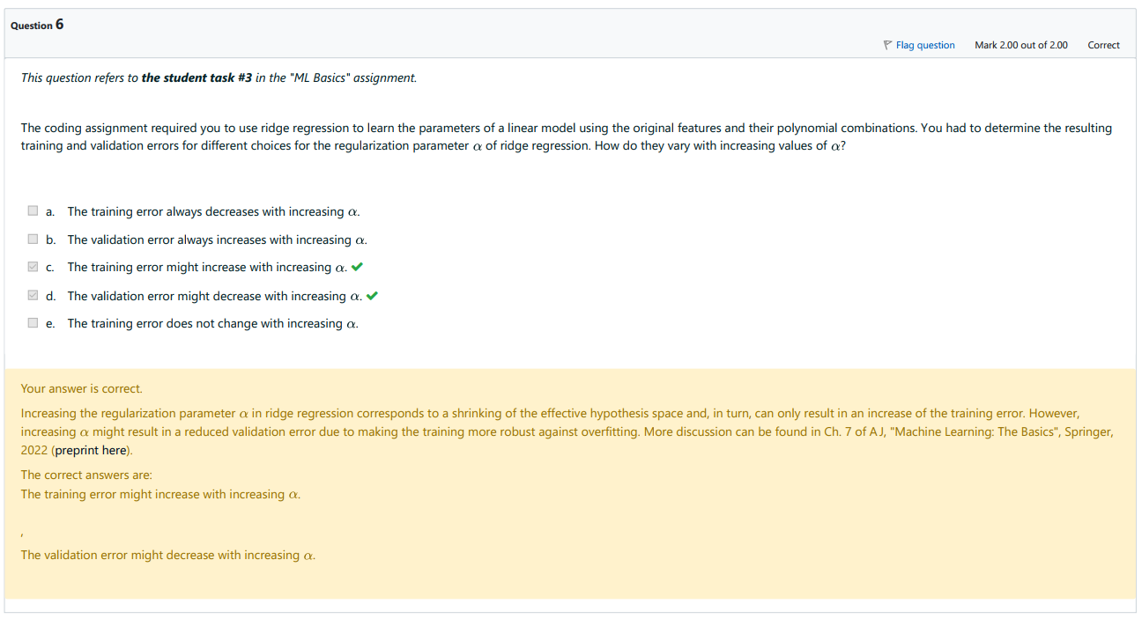

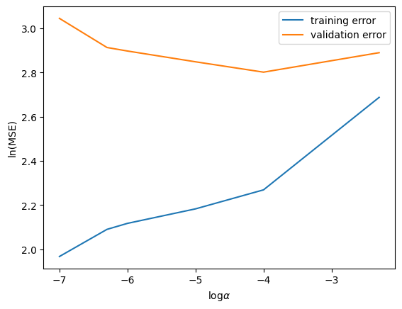

## 2. FL Design Principle

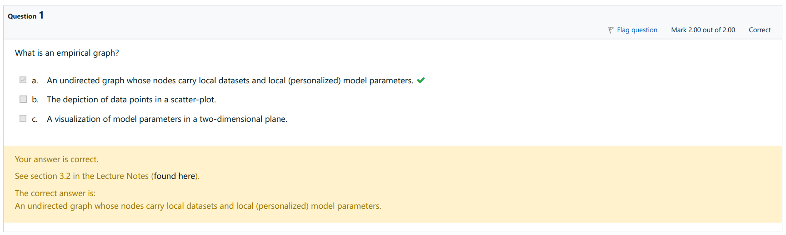

Lecture - "FL Design Principle", Empirical graphs and their Laplacian

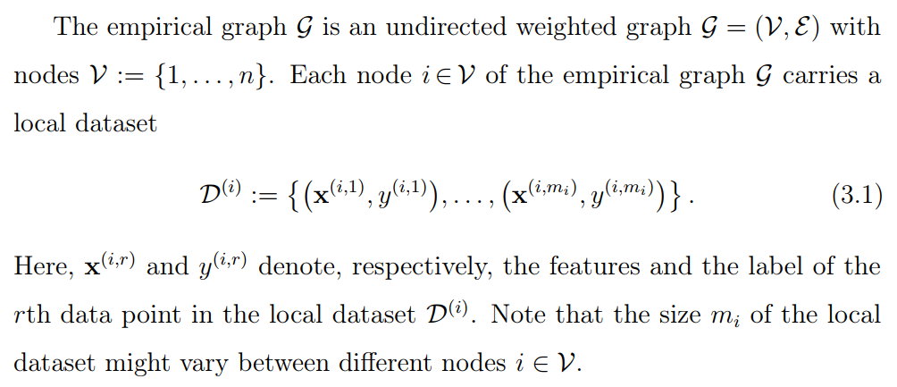

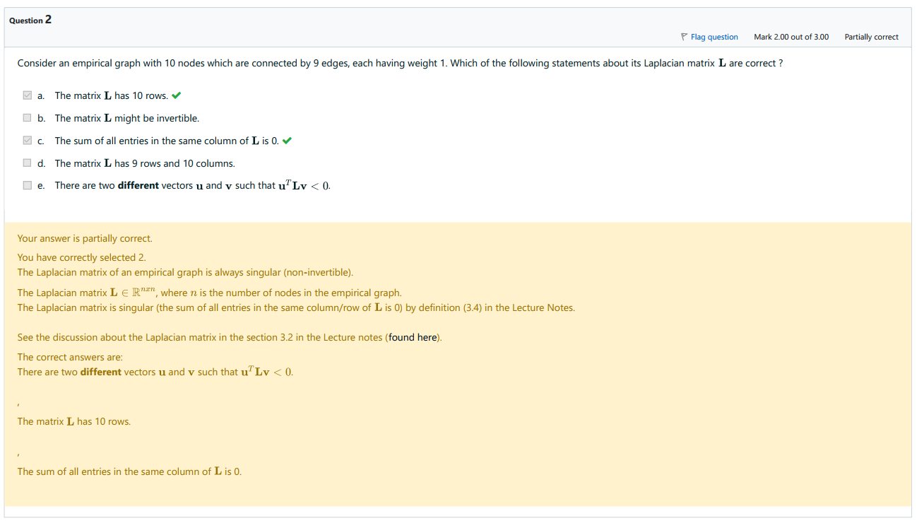

Lecture - "FL Design Principle", Empirical graphs and their Laplacian

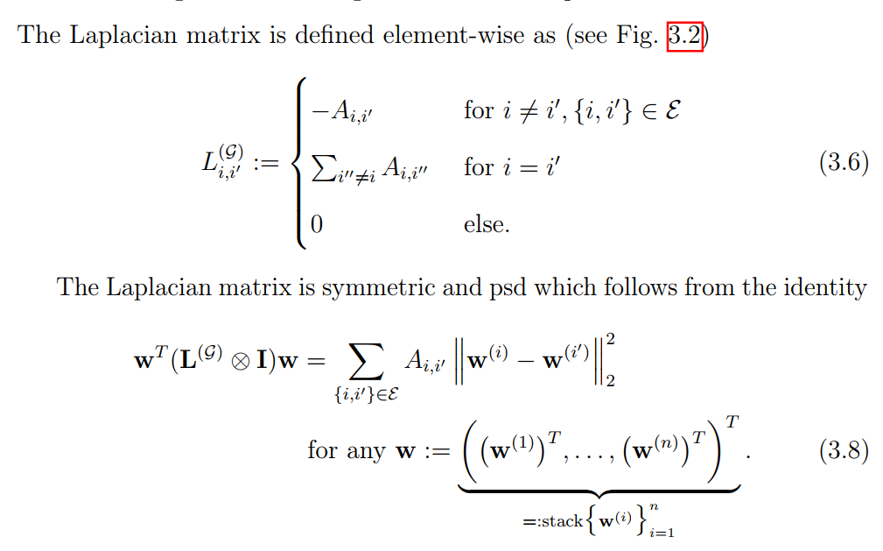

**Number of i is number of nodes, which is 10 => The matrix L has 10 rows**

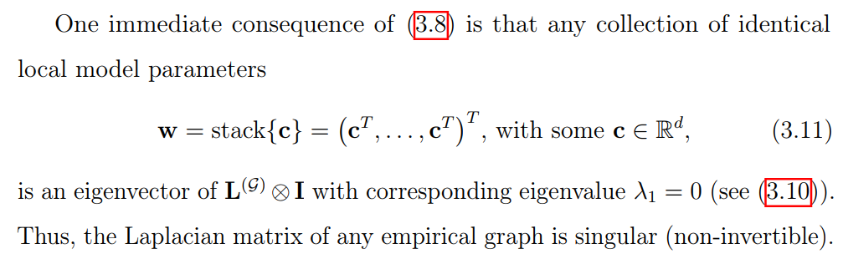

**=> The matrix X may be invertible is False**

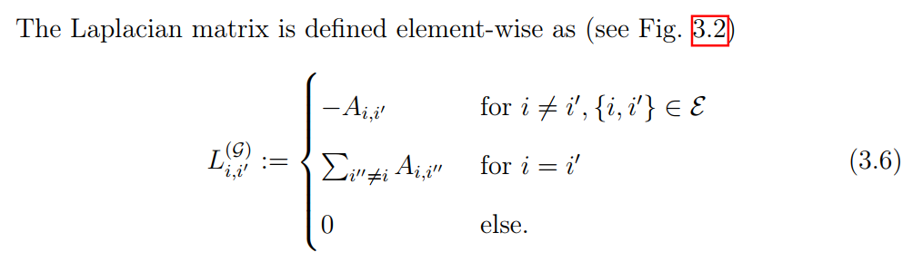

L = D - A, where D is degree matrix and A is adjacency matrix, which has 1 if there is an edge from node i to node j and 0 if these two nodes are not connected. Naturall the degree of a node (in matrix D) is equal to the number of the edges a node has (in matrix A), **which makes the column of L always has sum of 0** due to the formula D - A

As like before, L is a square matrix of dimension num nodes x num nodes => **it should be 10 x 10, not 9 x 10 (False)**

Don't be tricked by the last question. It is true that Laplacian matrix is positive semidefinite, which means uT L u is always non negative given any real value column vector u. **However the question asks about two separate vector u and v (THEY ARE NOT THE SAME VECTOR), so the answer naturally is True**

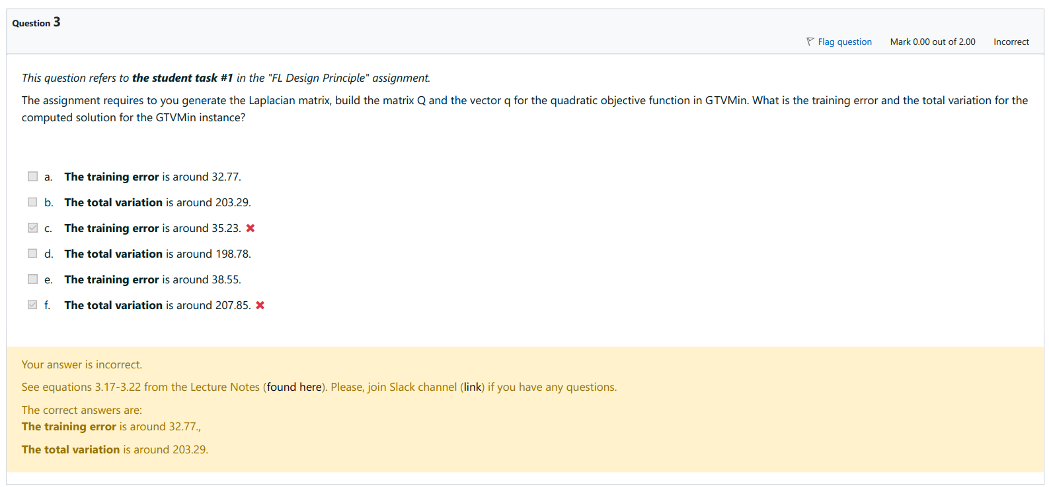

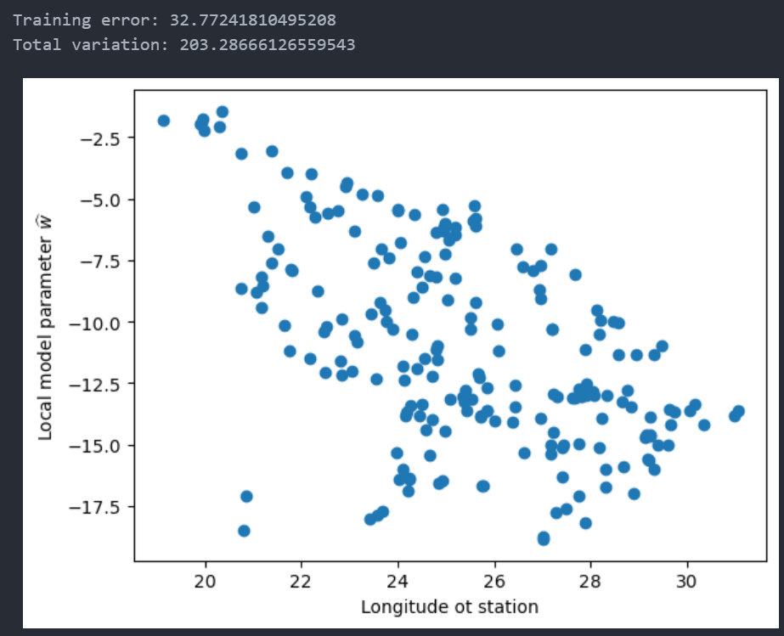

*# Generate the Laplacian matrix for the empirical graph.*

L_FMI = nx.laplacian_matrix(G_FMI).toarray()

*# Build matrix Q and vector q (Eq. (3.18)) for the quadratic objective*

*# function in GTVMin (see Eq. (3.17)) in the Lecture Notes.*

Q = np.eye(num_stations) + gtvmin_alpha * L_FMI

q = np.zeros(num_stations)

for iter_node in range(num_stations):

q[iter_node] = -2*np.sum(G_FMI.nodes[iter_node]['y']) / G_FMI.nodes[iter_node]['samplesize']

*# Use the zero-gradient condition (see Lecture Notes) to compute a solution for the GTVMin instance.*

hat_w = LA.inv(Q).dot(-0.5*q)

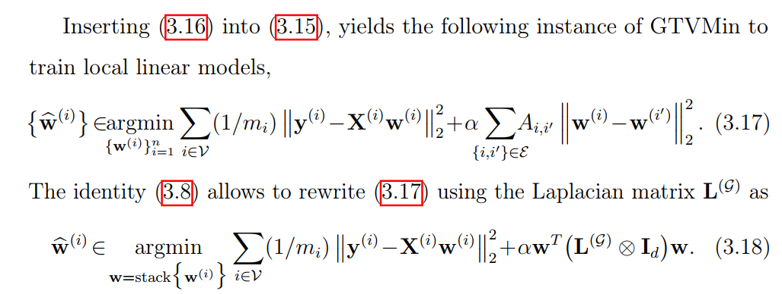

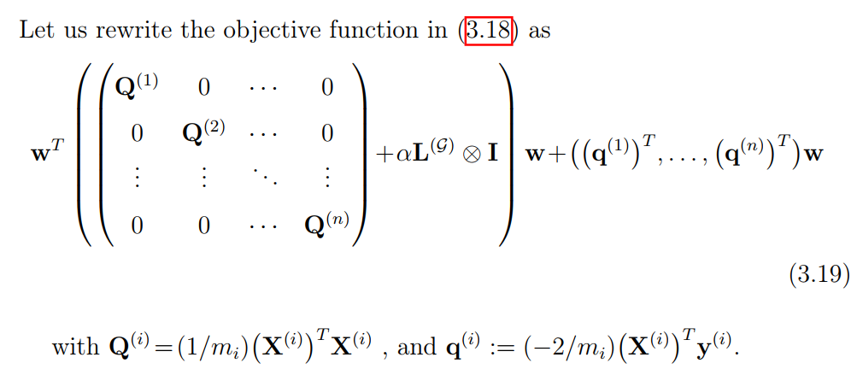

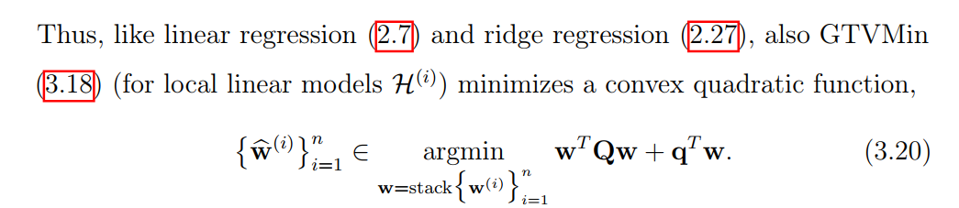

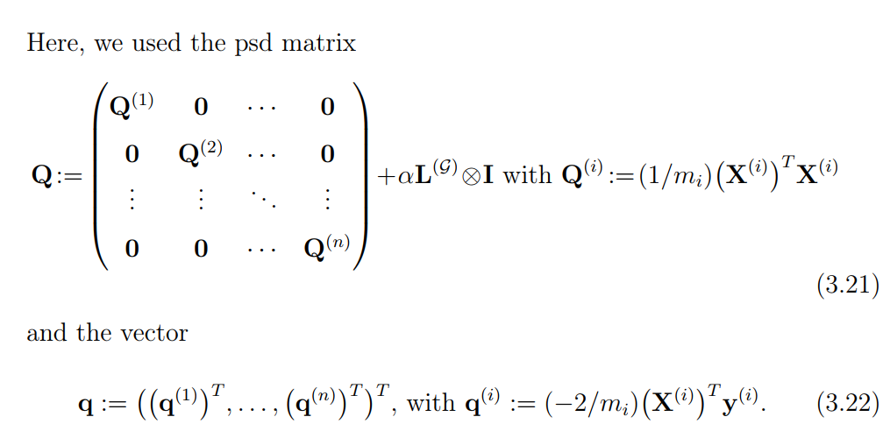

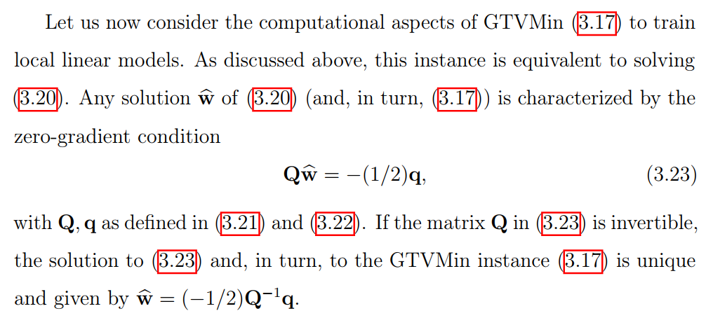

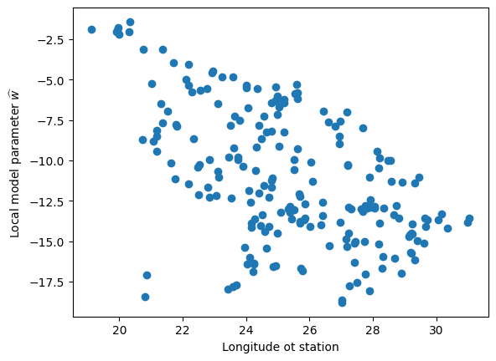

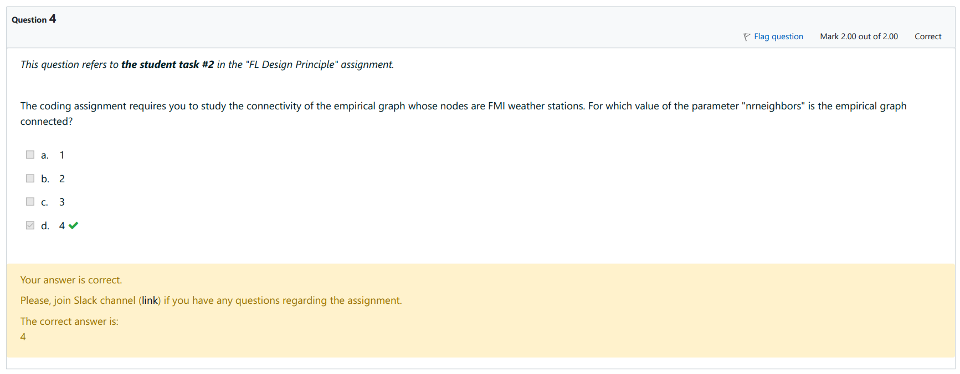

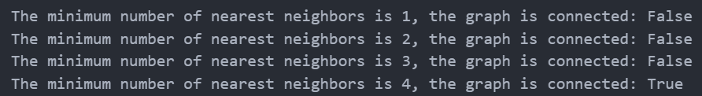

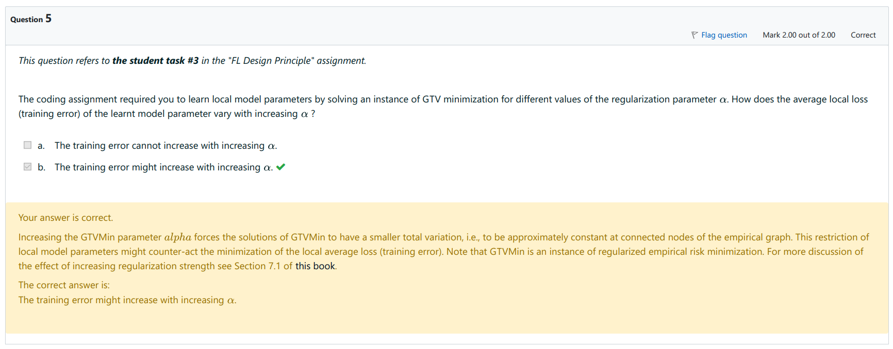

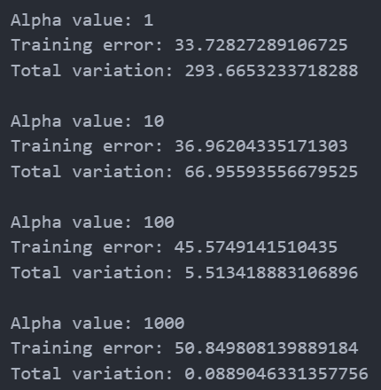

## 3. Gradient Methods

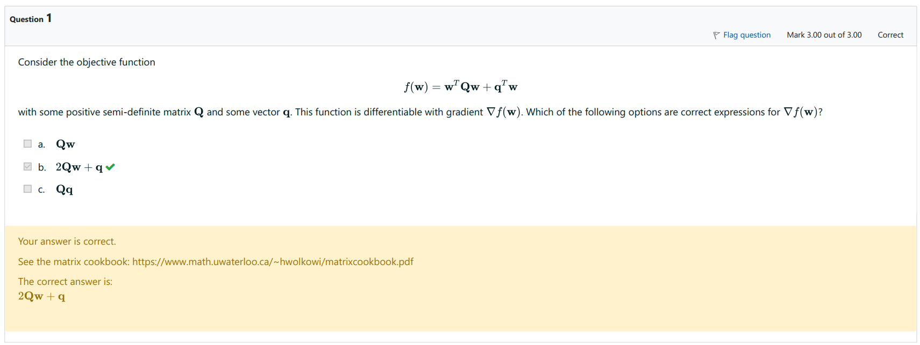

Lecture - "Gradient Methods", Gradient Descent

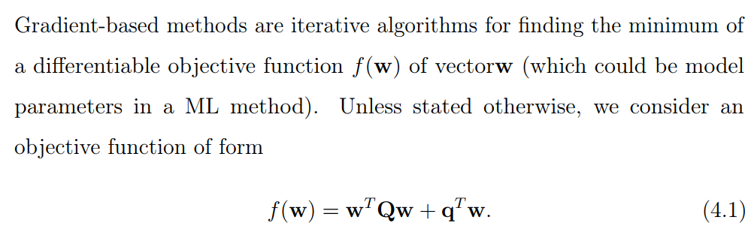

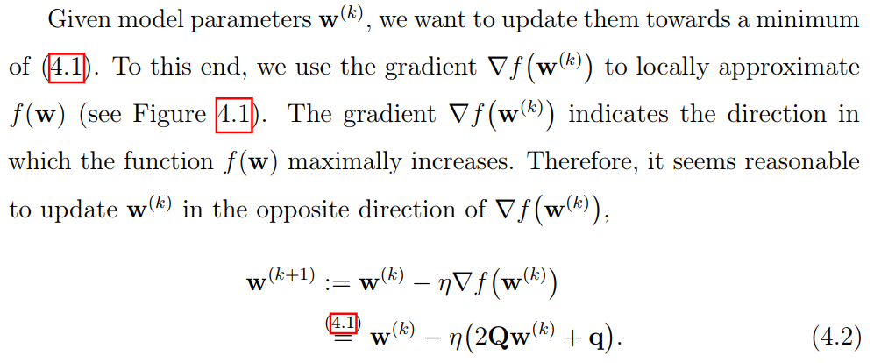

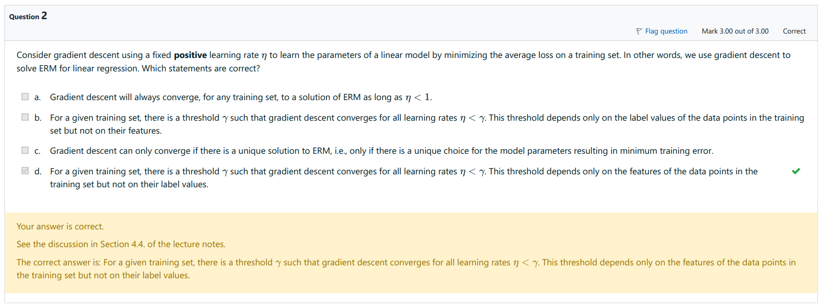

**a. is False** because there is no specific real value that always guarantee convergence if learning rate is smaller than this threshold. Convergence depends a lot on the labels and dataset, and the loss function.

**c. is False**. Imagine an objective function that has two local minima that minimize empirical risk (ERM). Now, which minima that the GD converges to would highly depend on the initial position of the descending point. So GD can converge even when there are many solutions to ERM.

b and d have the same idea in the first part, which is correct. Proof is inside

Lecture - "Gradient Methods", Learning rate

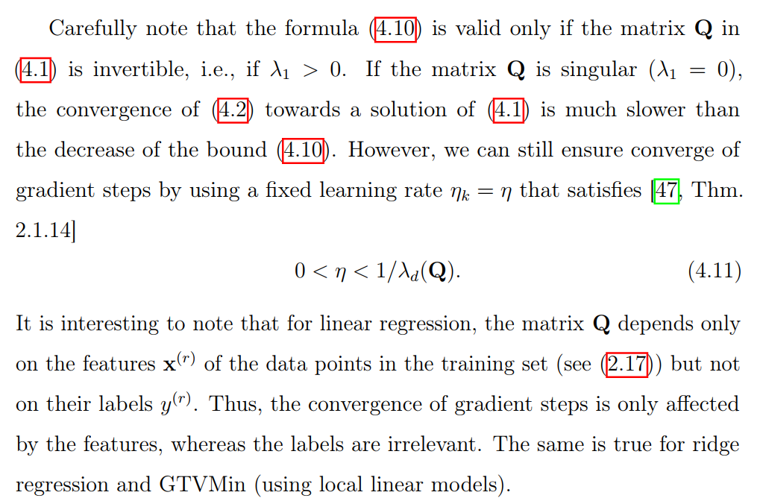

where gamma in question (b) and (d) is 1/ eigenvalue_d of matrix Q. This matrix Q only depends on the feature sets and not on the labels

**=> (b) is False and (d) is True**

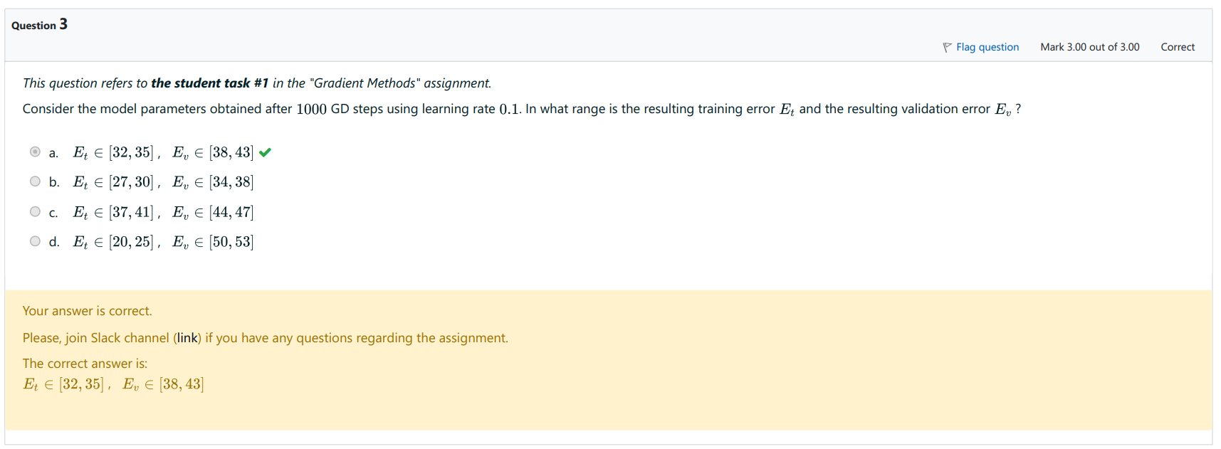

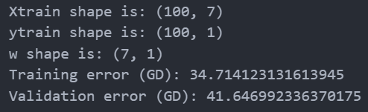

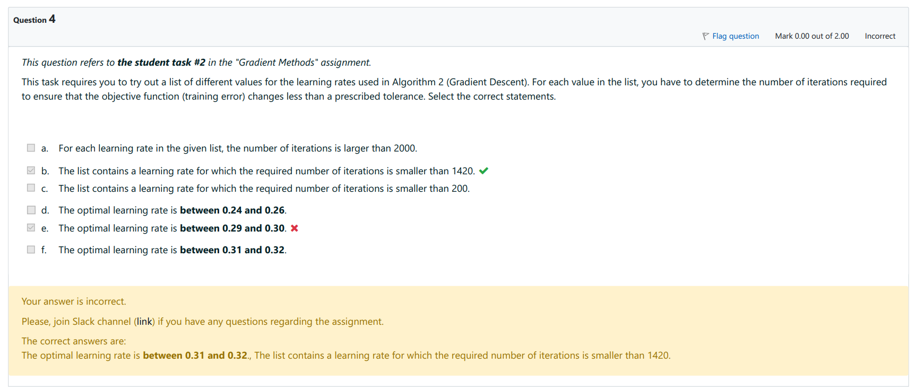

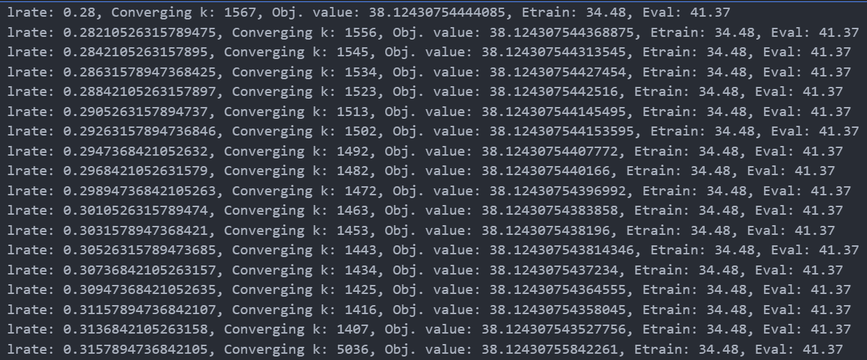

**a) False**, there are many converging k < 2000

**b) True**, which is where lrate = 0.31368 and 0.31157

**c) False**, all of them having k converge >= 1407

**(d), (e), (f), only (f) is correct**, where optimal learning rate is the one corresponding to smallest converge k, which is 1407. The optimal learning rate is thus 0.313684, inside [0.31, 0.32]

## 4. FL Algorithms

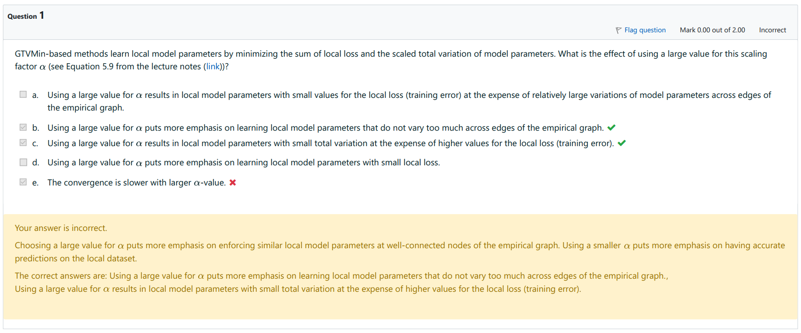

We can deal with (e) first. **(e) is False** because larger alpha value means that the GD will quickly tries to reduce the total variation between the edges. Choosing a large value for α puts more emphasis on enforcing similar local model parameters across the edges. This means that the large α can lead to faster convergence in terms of reaching a consensus across the network, because the regularization term that penalizes the difference between connected nodes' parameters has a stronger influence. The nodes are 'encouraged' to agree with each other more strongly, which might lead to a quicker agreement across the network. A large α can smooth out variations due to noisy local gradients, which might otherwise lead to large, oscillating updates. This smoothing effect could help stabilize convergence, as the updates become more consistent across iterations.

Lecture - "FL Algorithms", Message Passing Implementation

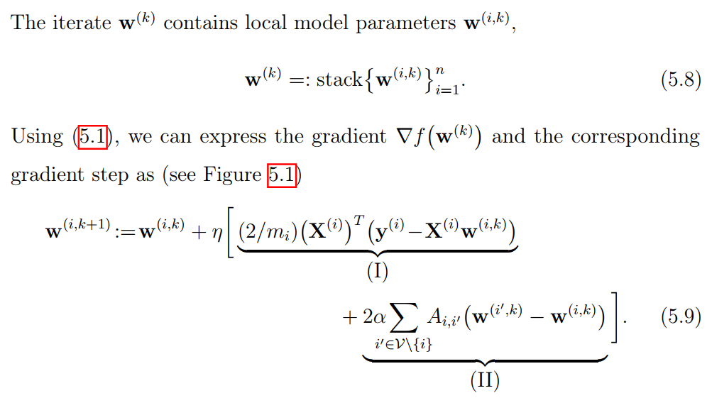

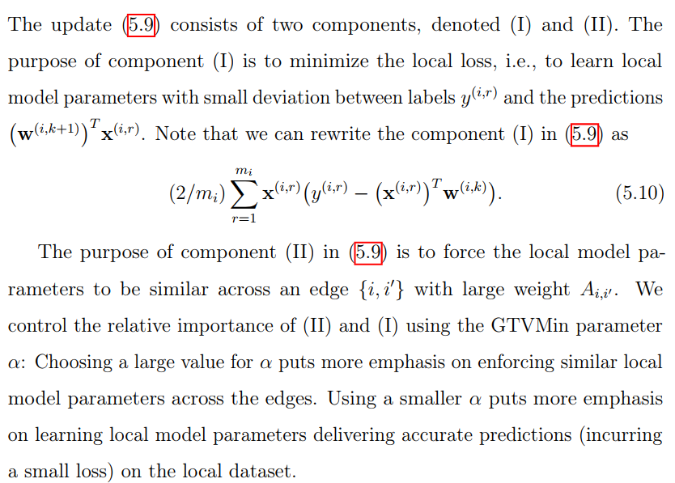

From this passage, it is clear that **(a)(d) are False and (b)(c) are True**.

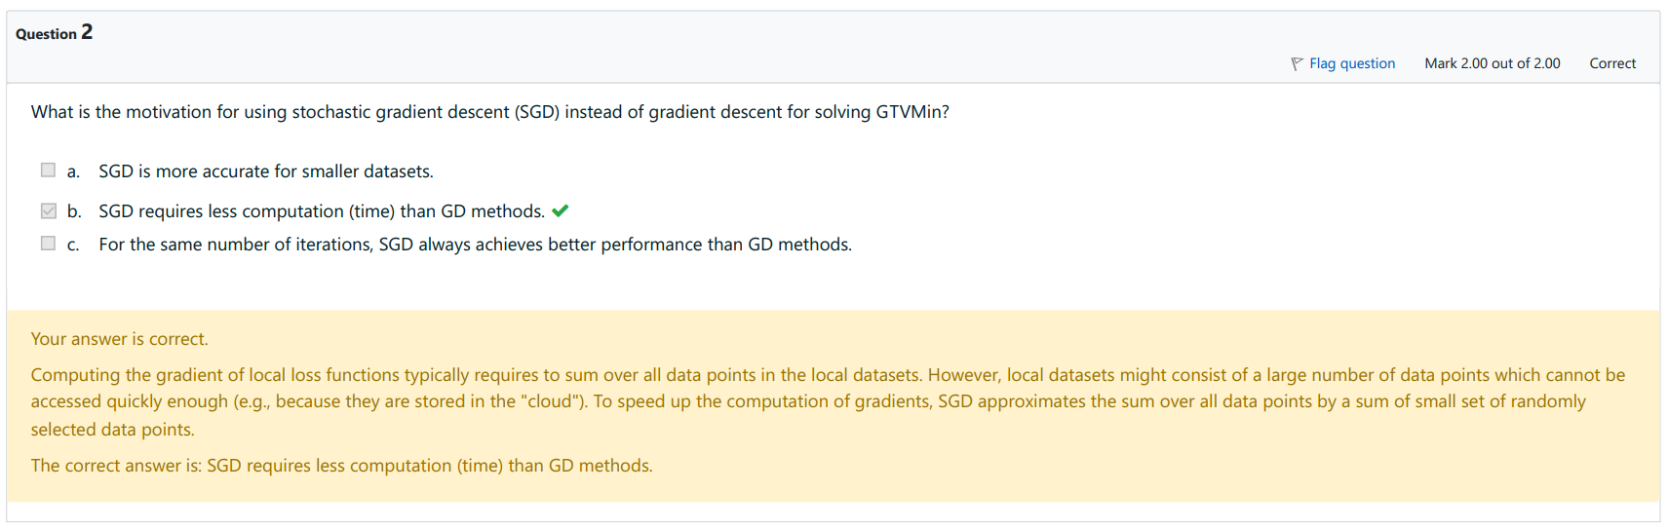

Lecture - "FL Algorithms", FedSGD

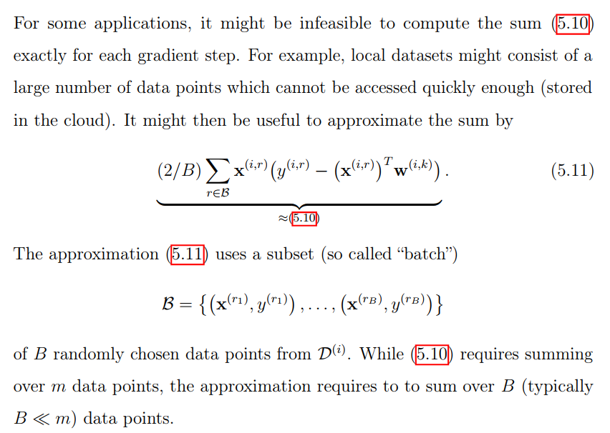

From this, **(b) is clearly True.** However, (a) and (c) are not mentioned anywhere, so we need some logic to think about them

**a is False.** The accuracy of SGD compared to GD is not inherently better for smaller datasets. In fact, because SGD estimates the gradient based on a single sample or a small batch of samples, it can be noisier than the gradient computed over the entire dataset, as is done in GD.

**c is False**. It is not guaranteed that SGD will always outperform GD for the same number of iterations. SGD can sometimes converge faster to a good solution or escape local minima due to its noisy gradient updates, but it doesn't always lead to better performance, especially if we define performance in terms of reaching the exact minimum of the loss function.

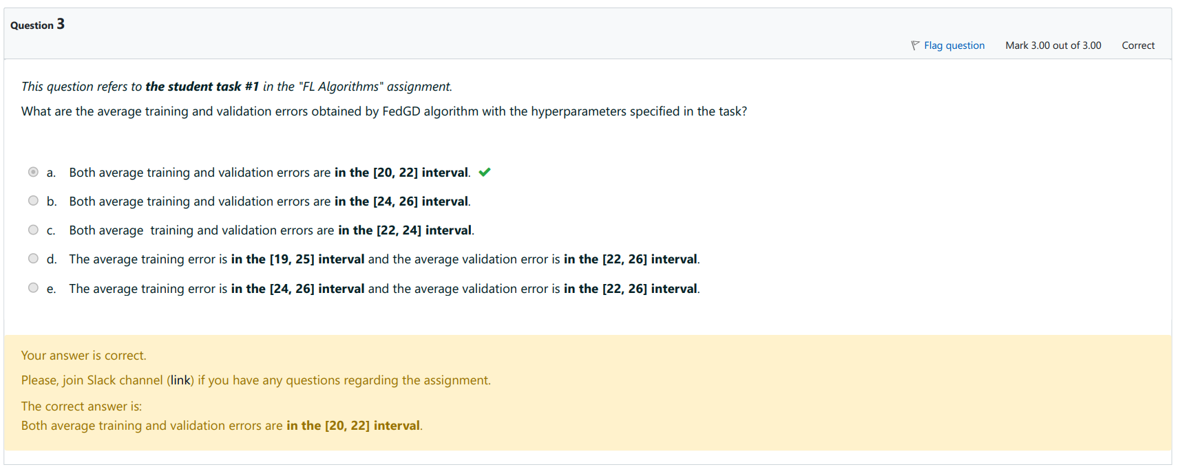

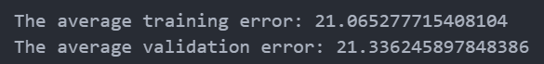

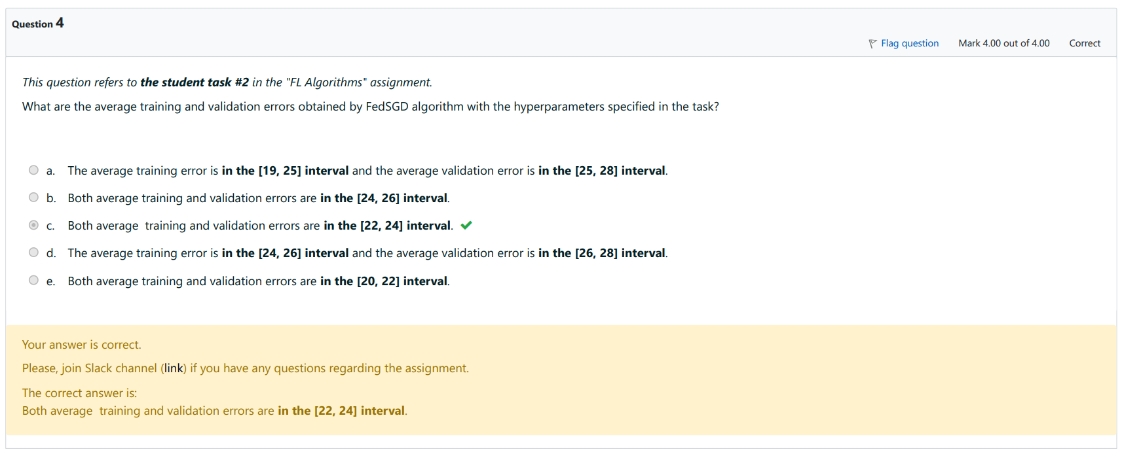



## 5. FL Flavors

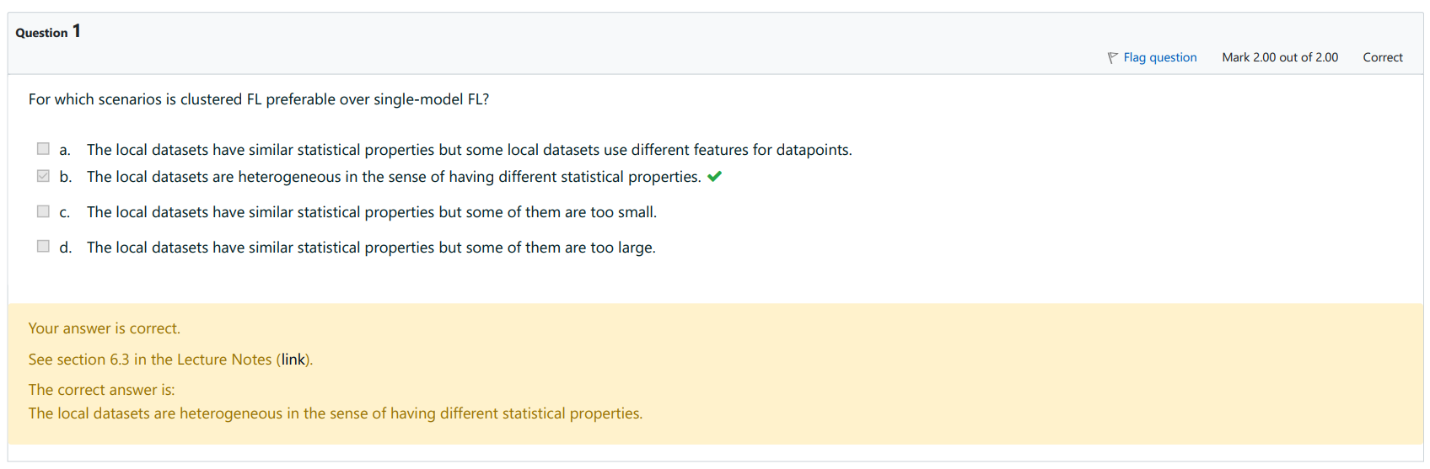

Lecture - "FL Flavors", Clustered FL

**a) is False.** The local datasets have similar statistical properties but some local datasets use different features for datapoints. When local datasets use different features for datapoints, the scenario typically uses vertical FL, where different datasets Di hold different pieces of information about the same entities.

**b) is True.** The local datasets are heterogeneous in the sense of having different statistical properties.

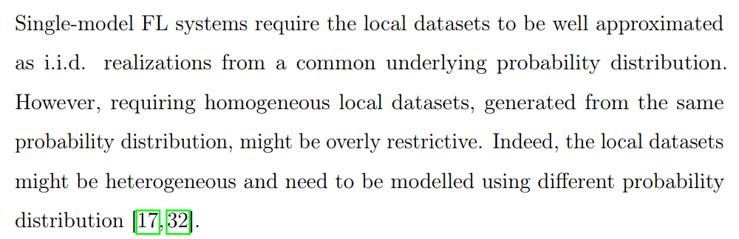

**c) is False**. The local datasets have similar statistical properties but some of them are too small.

**d) is False.** The local datasets have similar statistical properties but some of them are too large.

The size of the local datasets (whether too small or too large) does not directly influence the preference for clustered FL over single-model FL. Instead, the key factor is the heterogeneity in the statistical properties of the datasets.

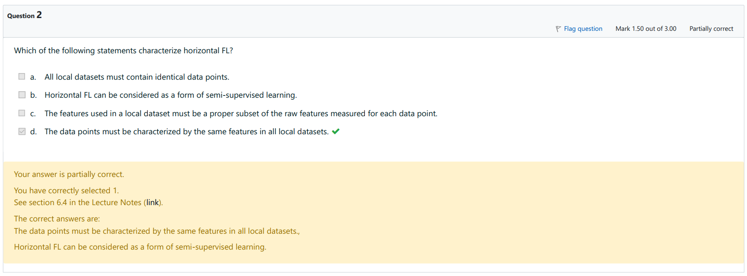

Lecture - "FL Flavors", Horizontal FL

**a) is False.** All local datasets may have different data points. This is a characteristic of HFL. In fact, HFL specifically deals with the scenario where datasets across different nodes contain different data points but share the same feature space.

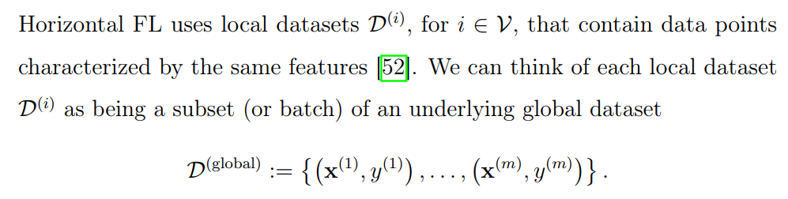

**b) is True.** Horizontal FL can be considered as a form of semi-supervised learning.

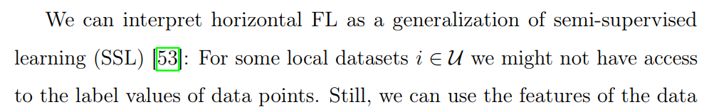

**c) is False.** The features used in a local dataset must contain all raw features measured for each data point, not just a proper subset. In Horizontal FL, the datasets across all participating nodes are expected to have the same set of features, not subsets of features.

**d) is True.** The data points must be characterized by the same features in all local datasets.

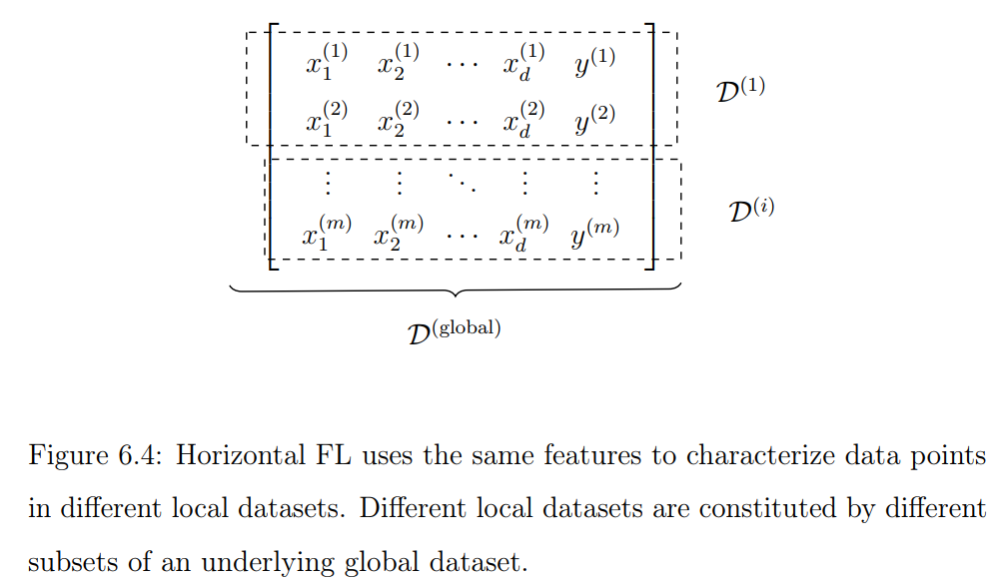

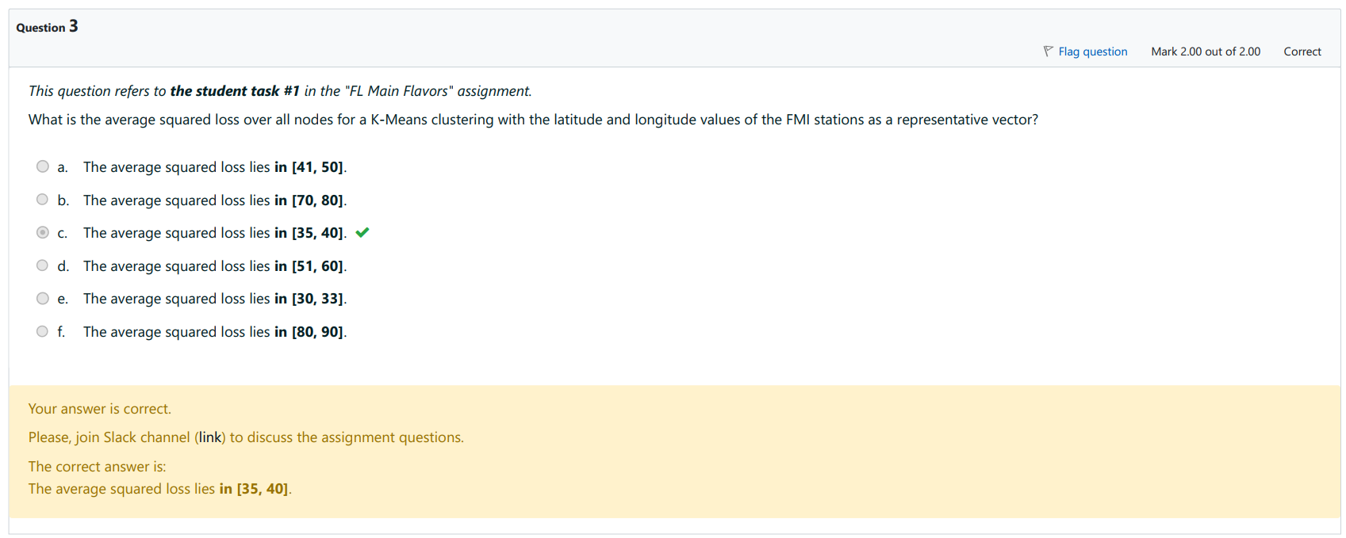



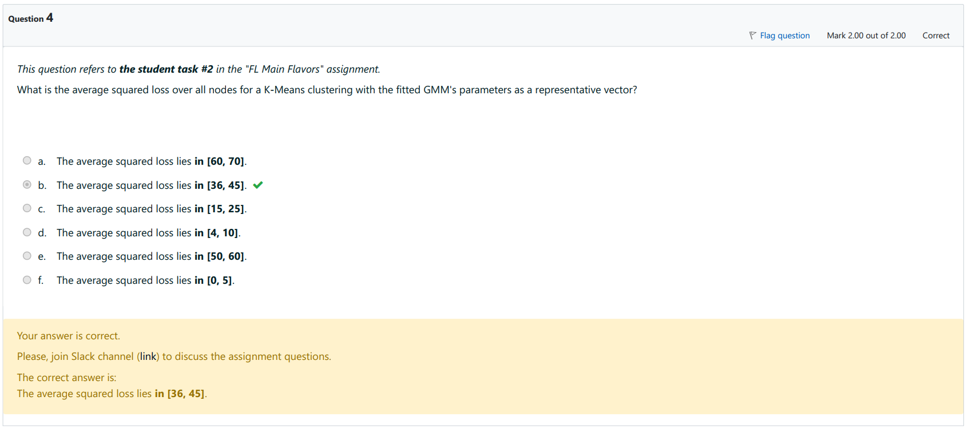



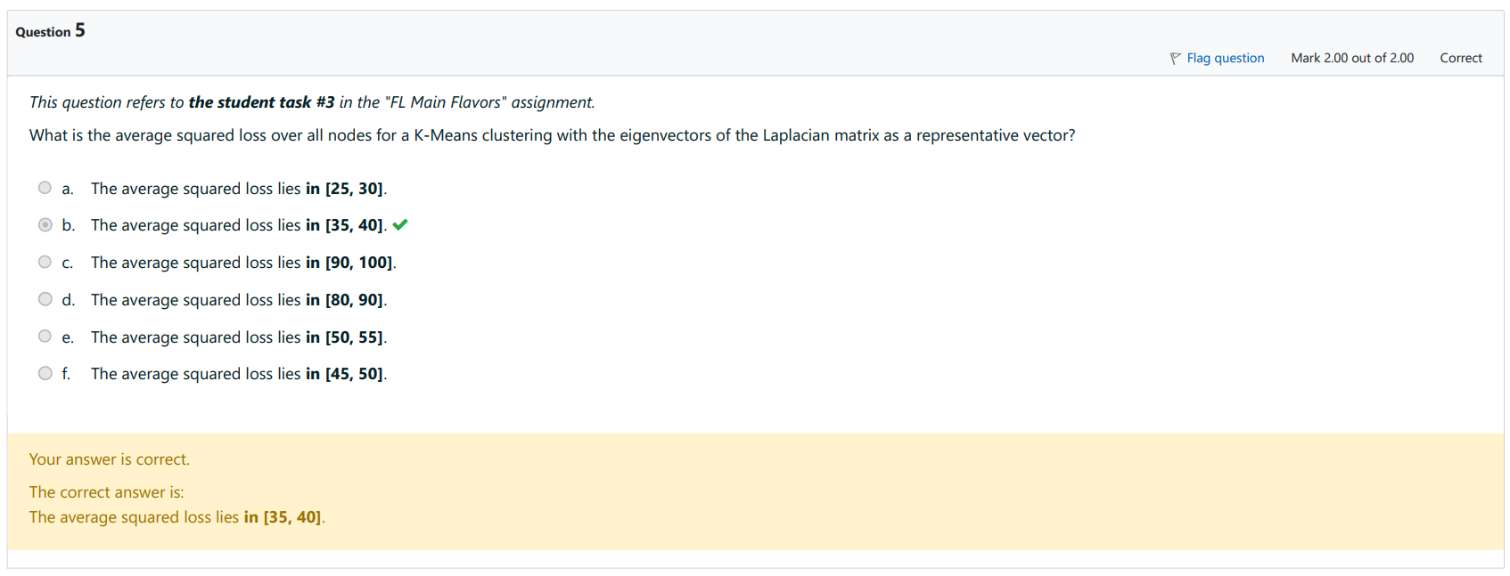



## 6. Graph Learning

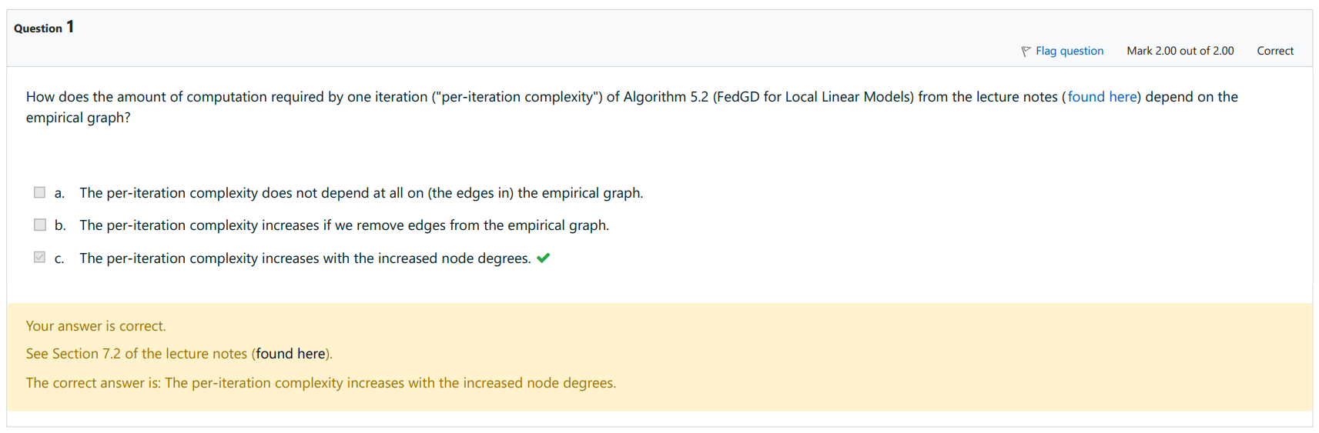

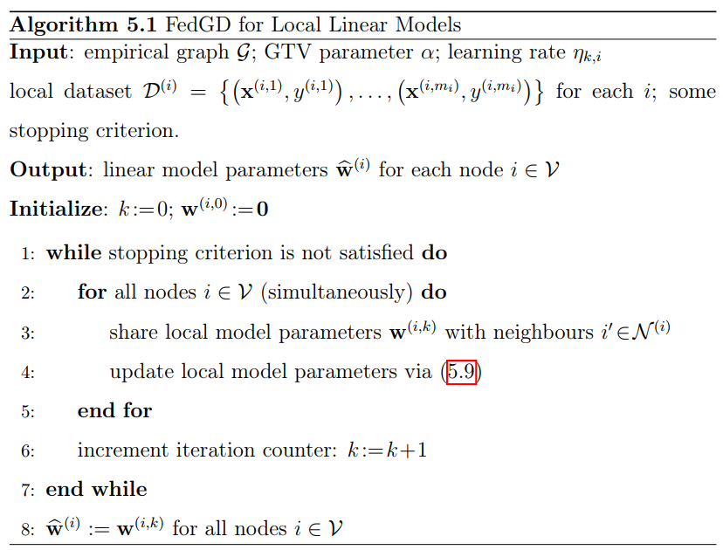

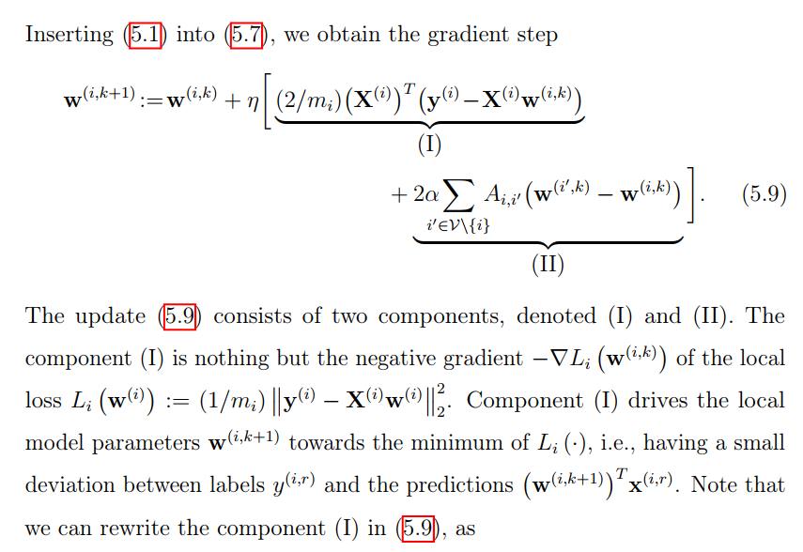

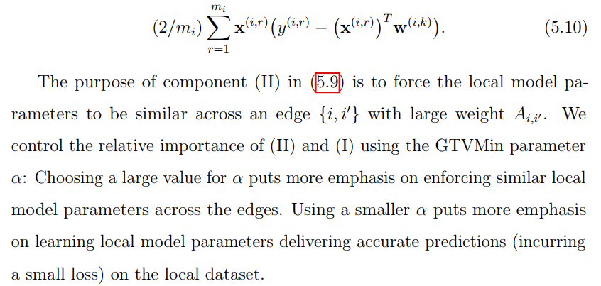

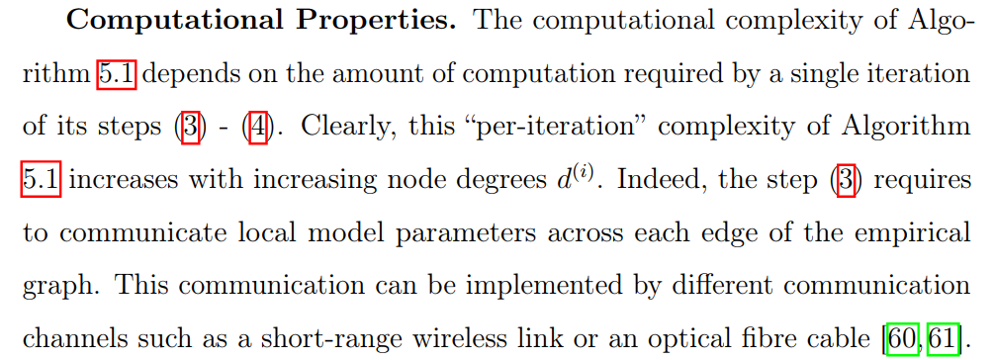

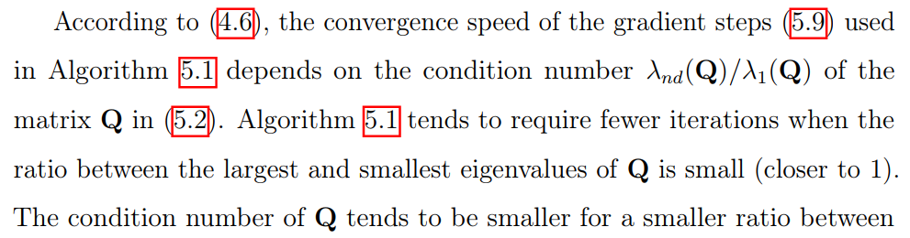

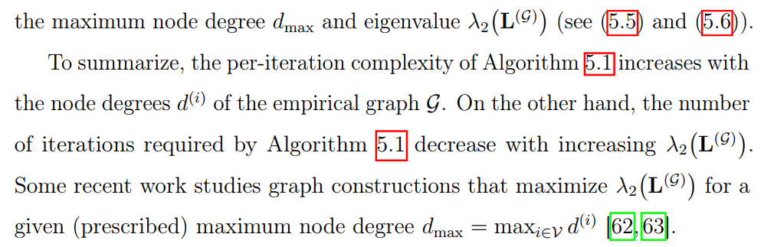

The per iteration complexity of algorithm 5.1 increases with node degrees of empirical graph G => (a) (b) are False and (c) is True

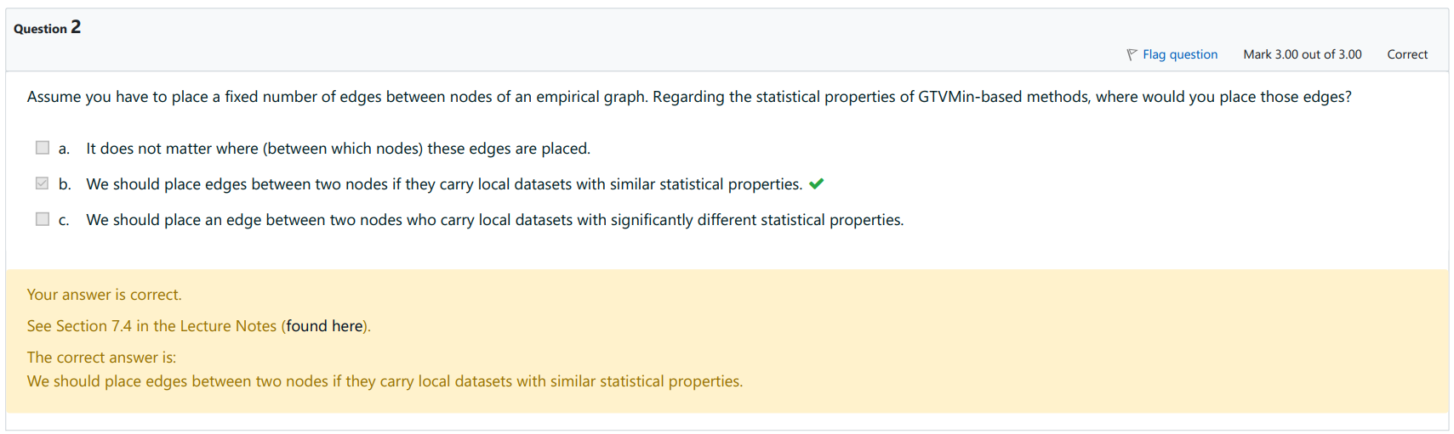

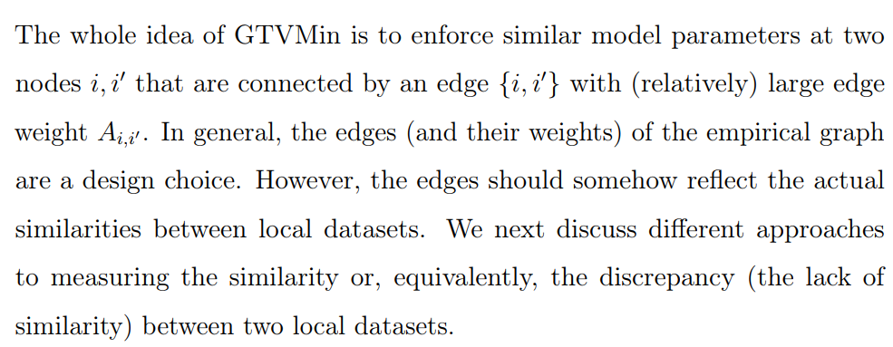

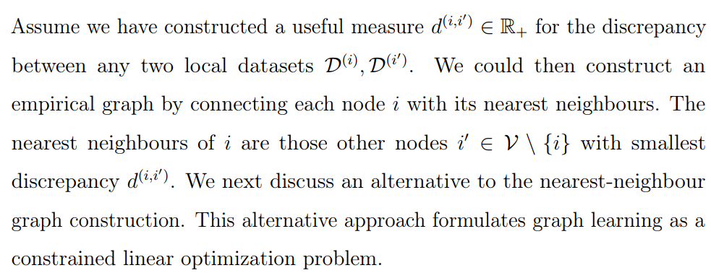

From these two paragraphs, (a) and (c) are False, and (b) is True

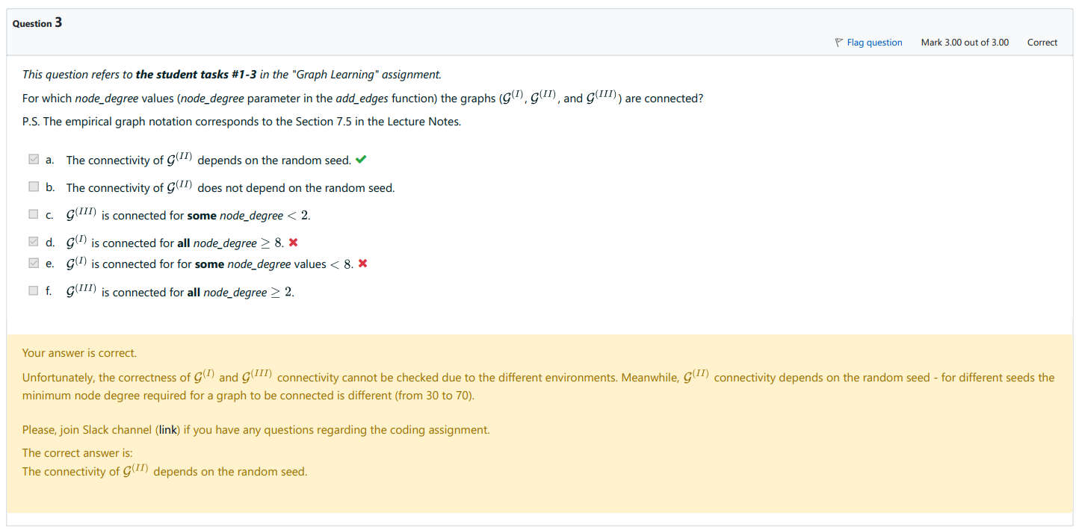

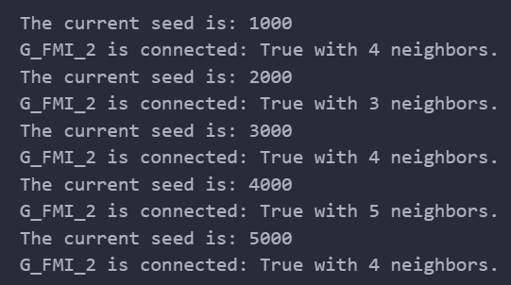

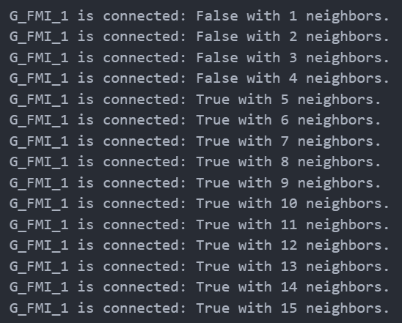

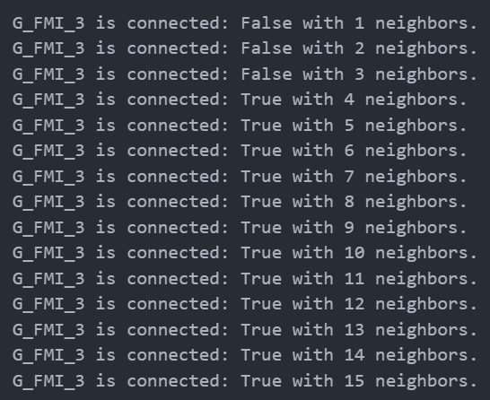

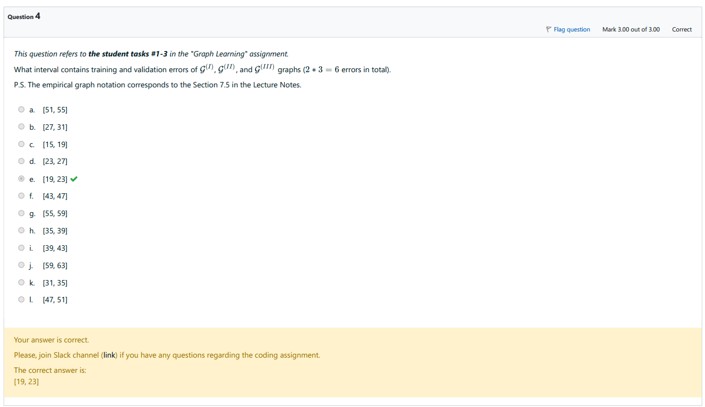

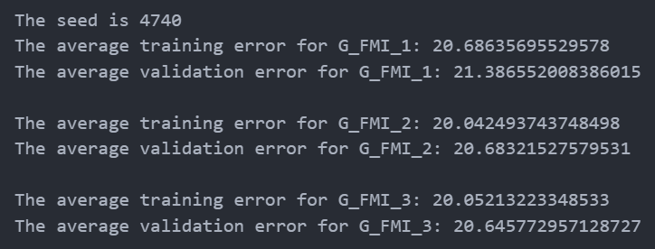

## 7. Trustworthy AI

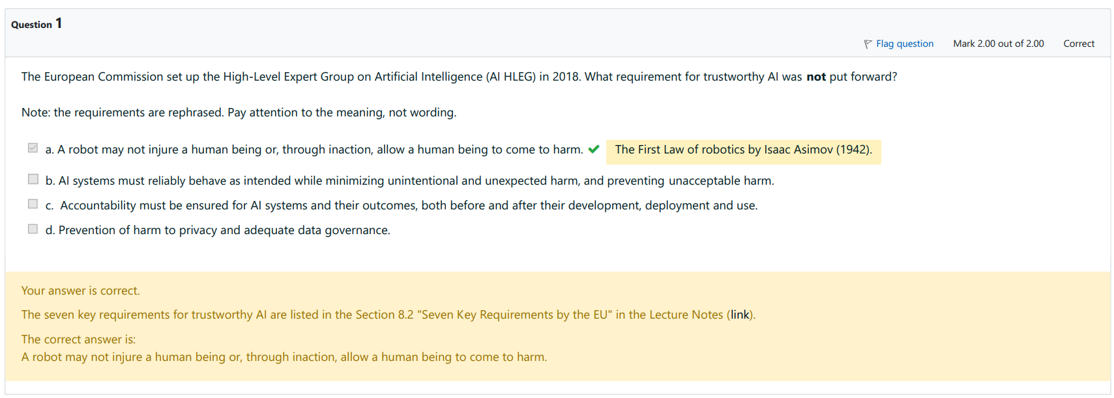

(a) is made up

(b) is 8.2.2

(c) is 8.2.7

(d) is 8.2.3

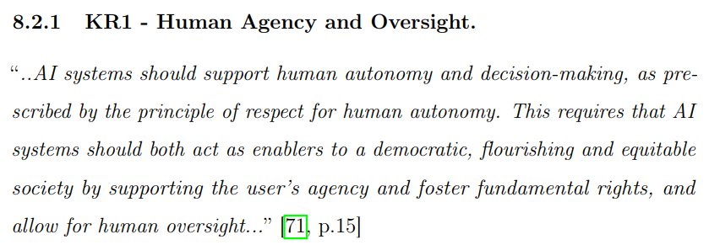

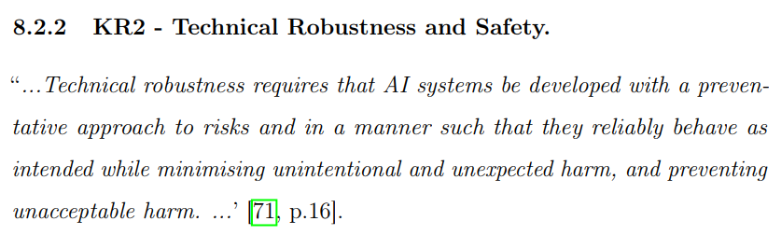

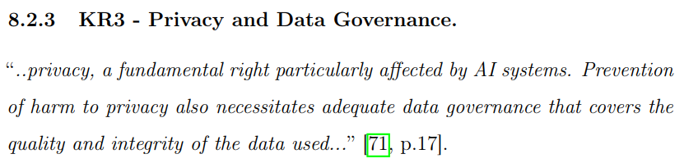

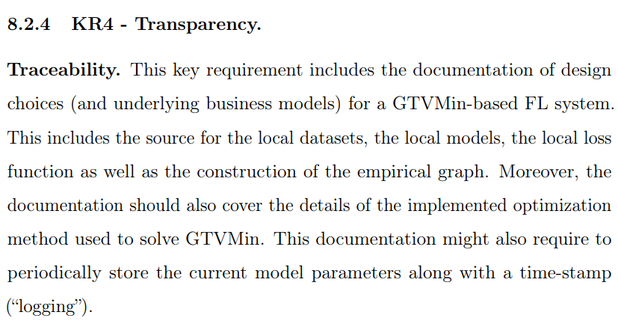

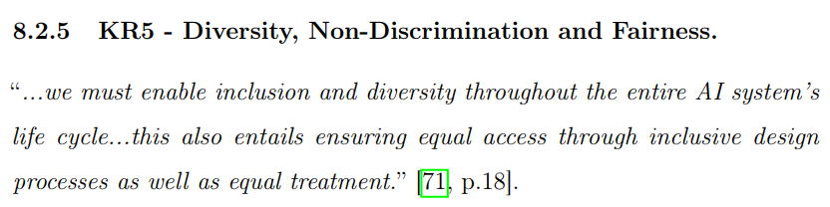

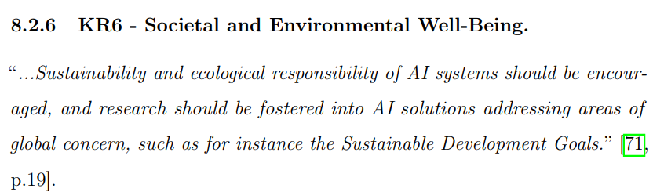

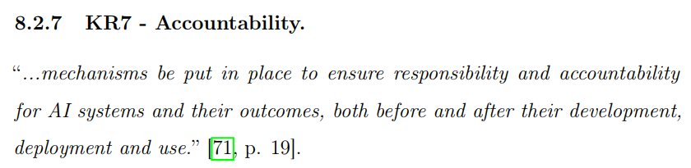

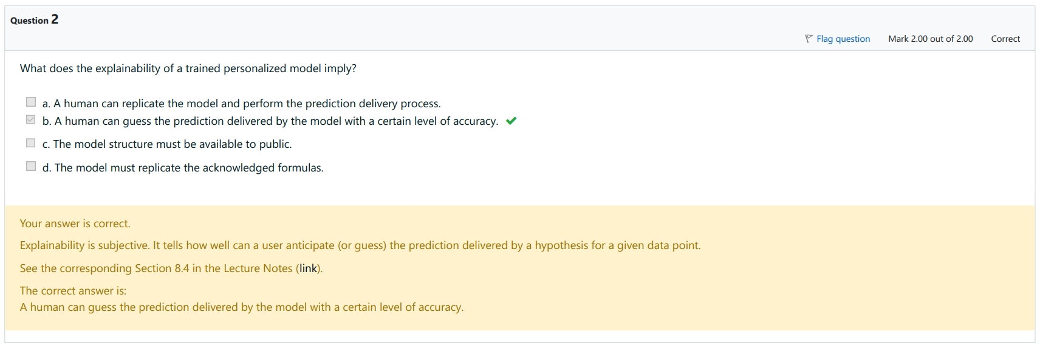

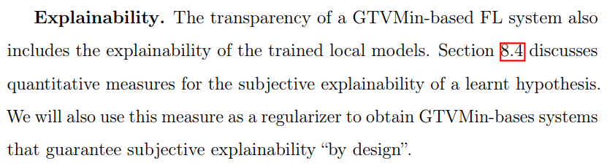

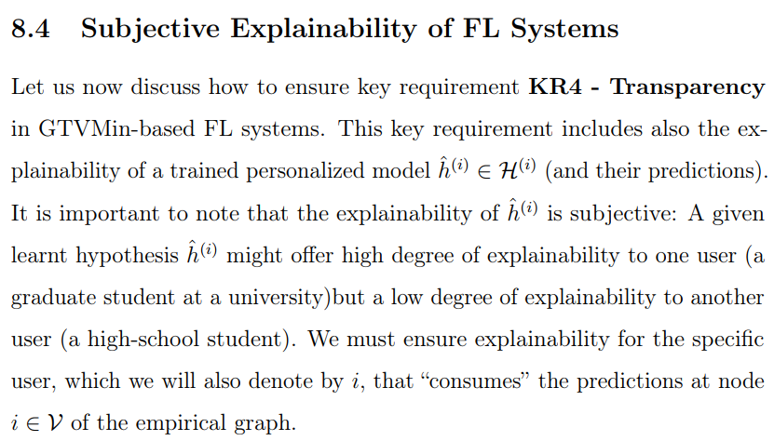

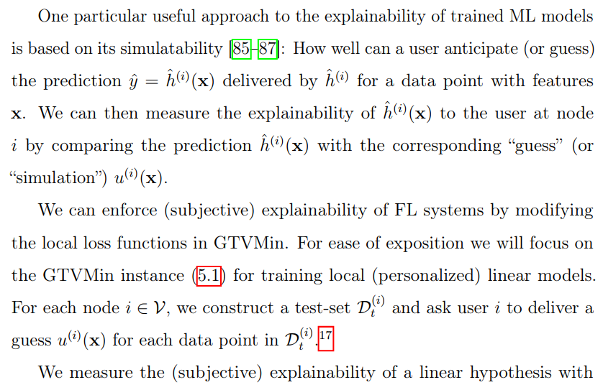

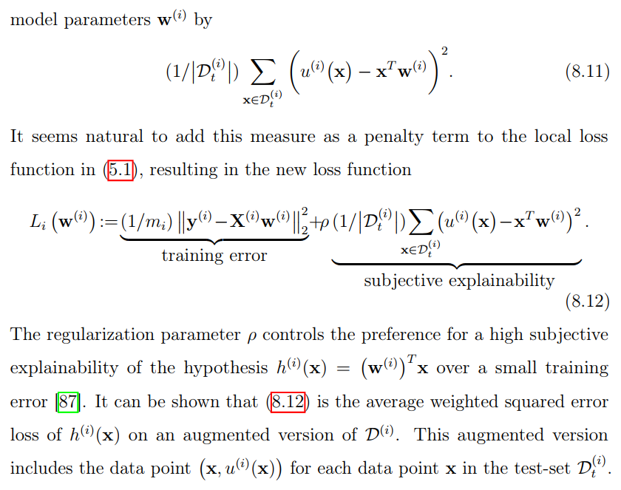

From here, we can see that (c) and (d) are irrelevant. However, (a) and (b) are more difficult to to tell apart. From the text, they say that explainability means how certain a human can make a prediction for a datapoint with feature X. It does not mention that human must have access to the physical model in (a) to make a prediction, but they are only required to guess the output with some certainty. Therefore, only (b) is correct.

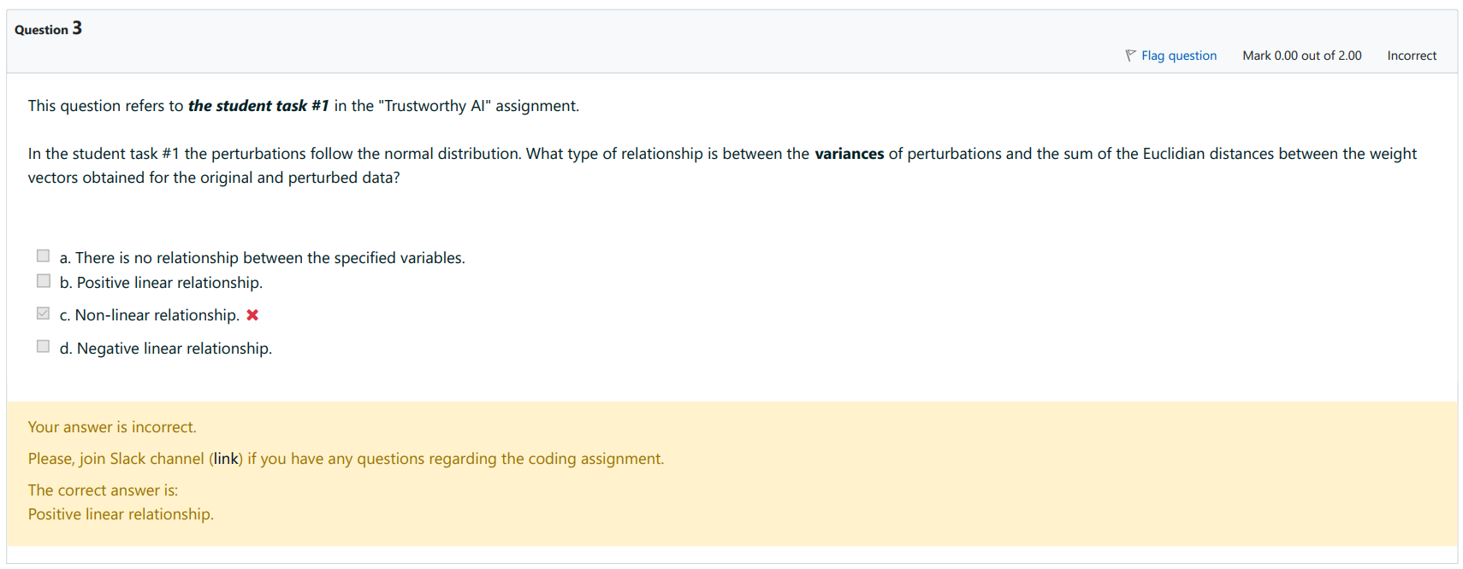

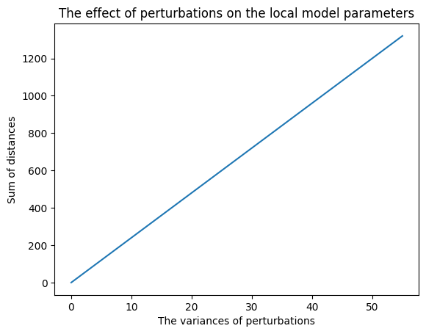

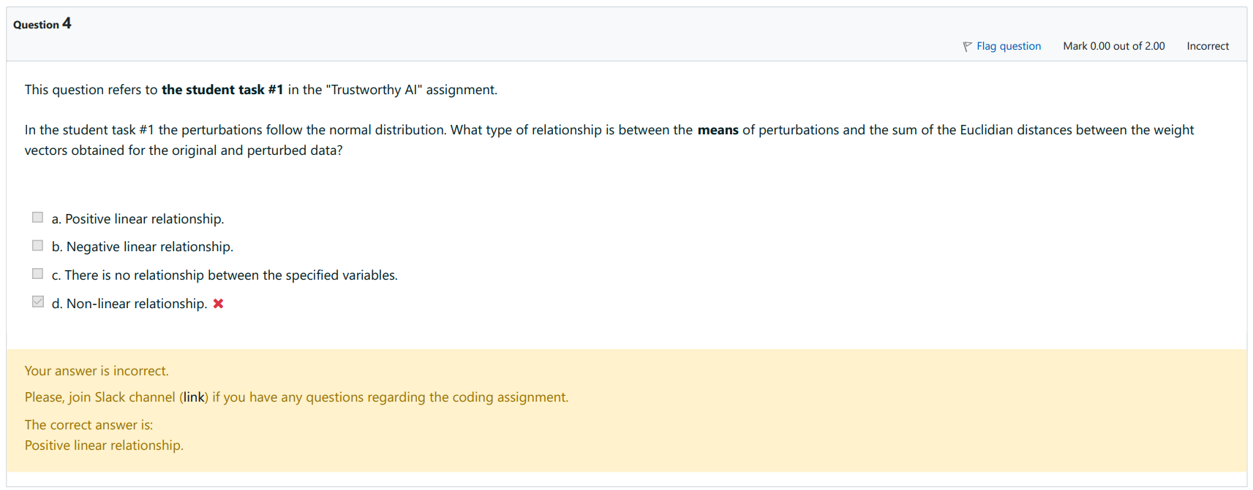

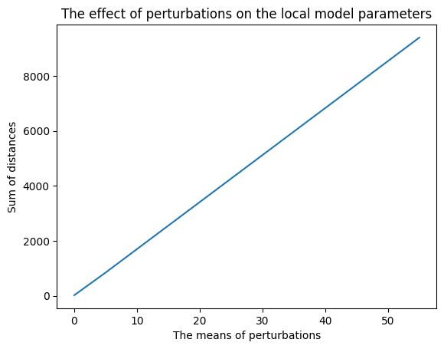

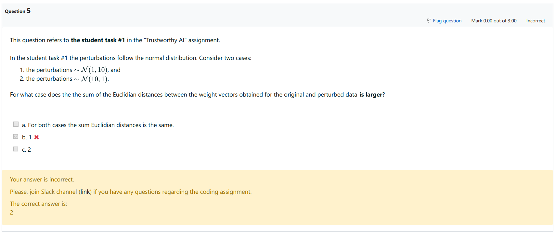

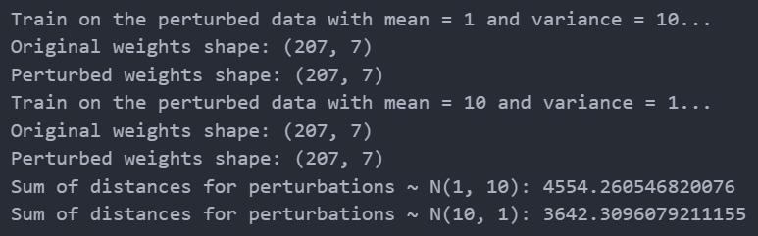

Which is wrong, as N(10, 1) should have larger perturbation. This question is unsure.

## 8. Privacy in AI

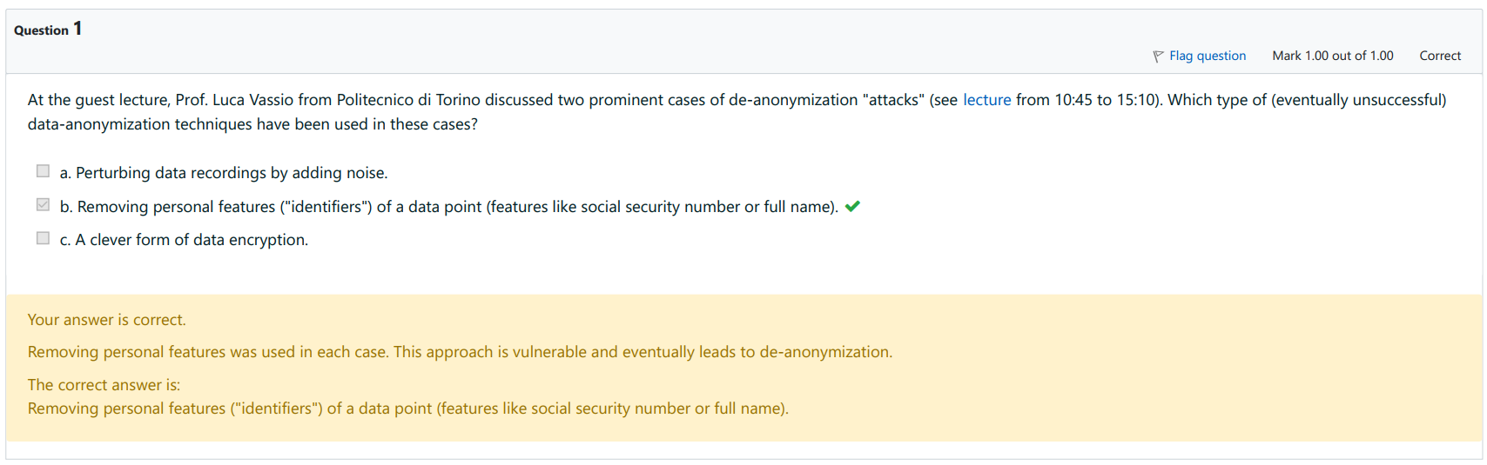

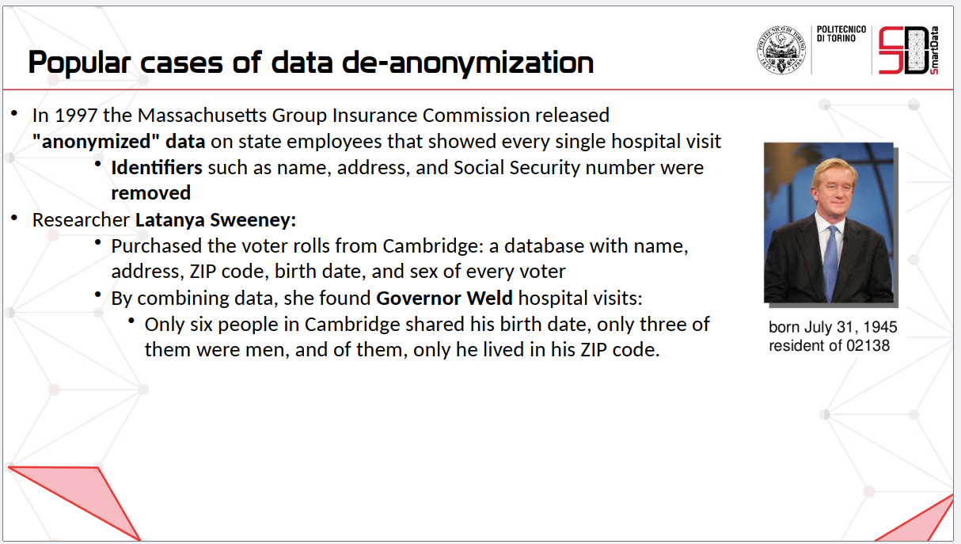

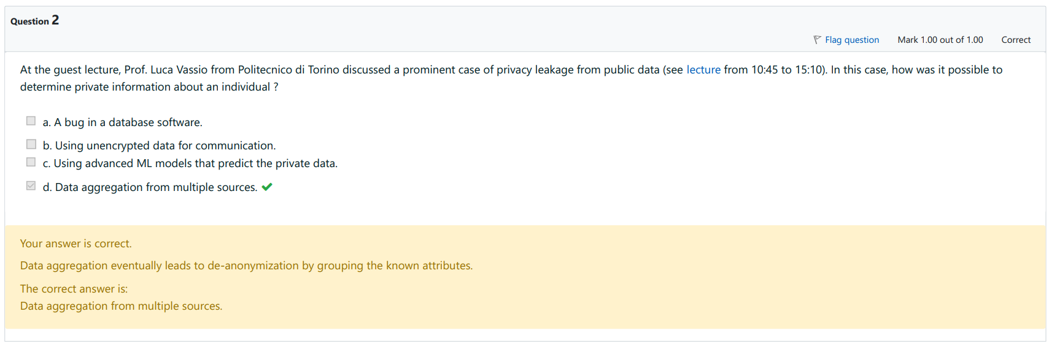





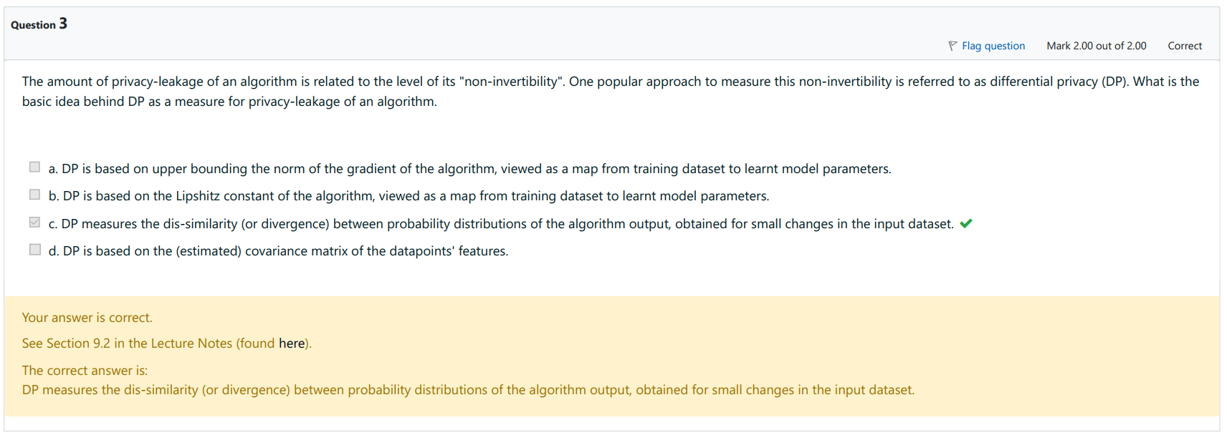

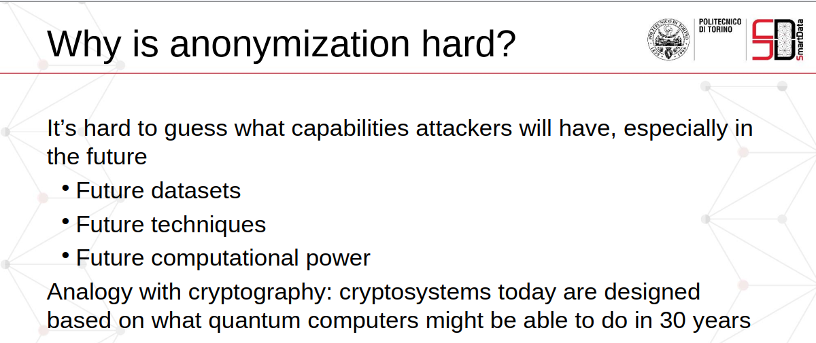

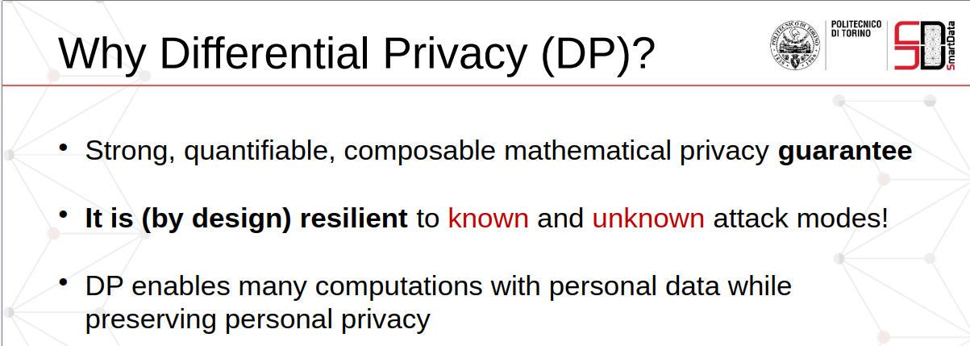

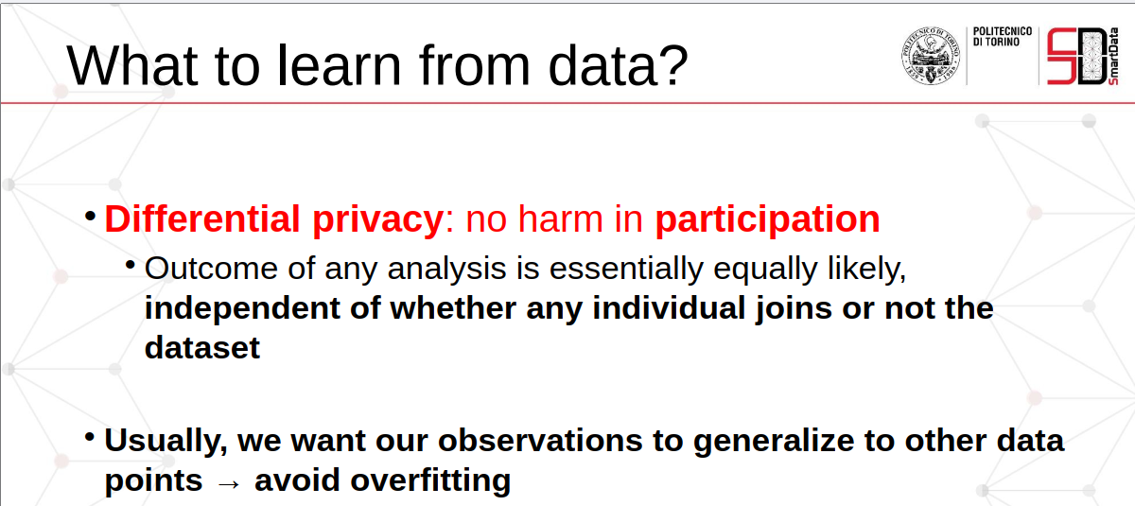

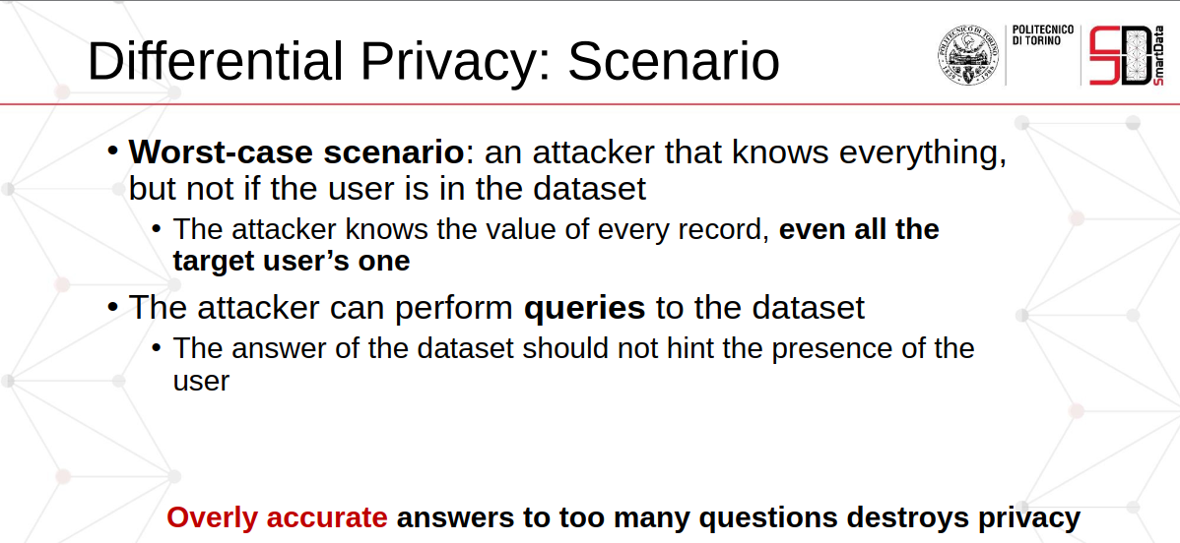

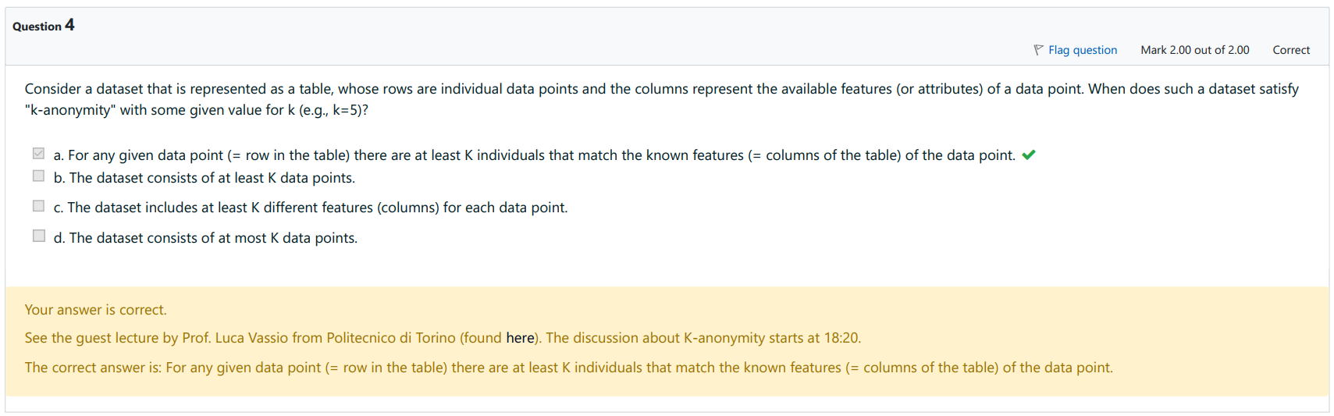

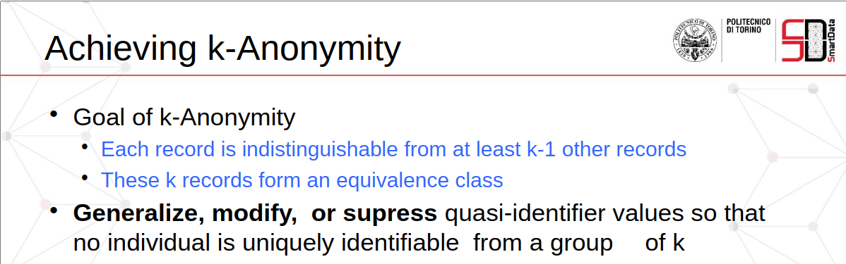

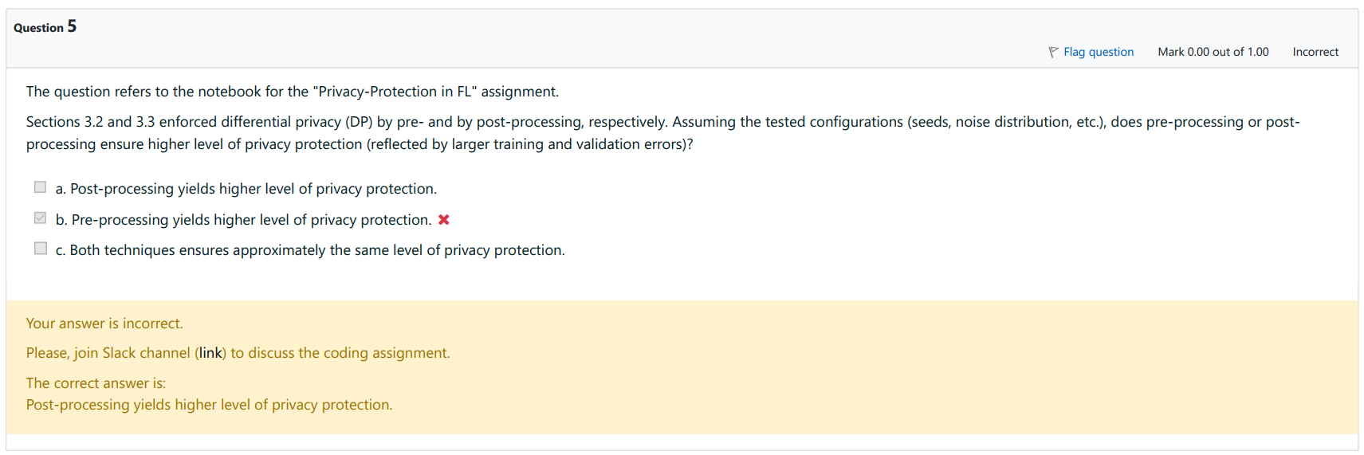

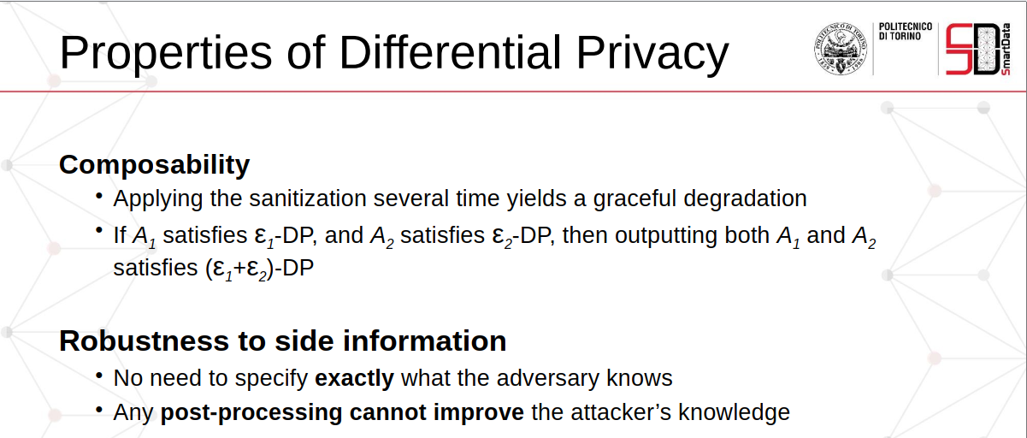

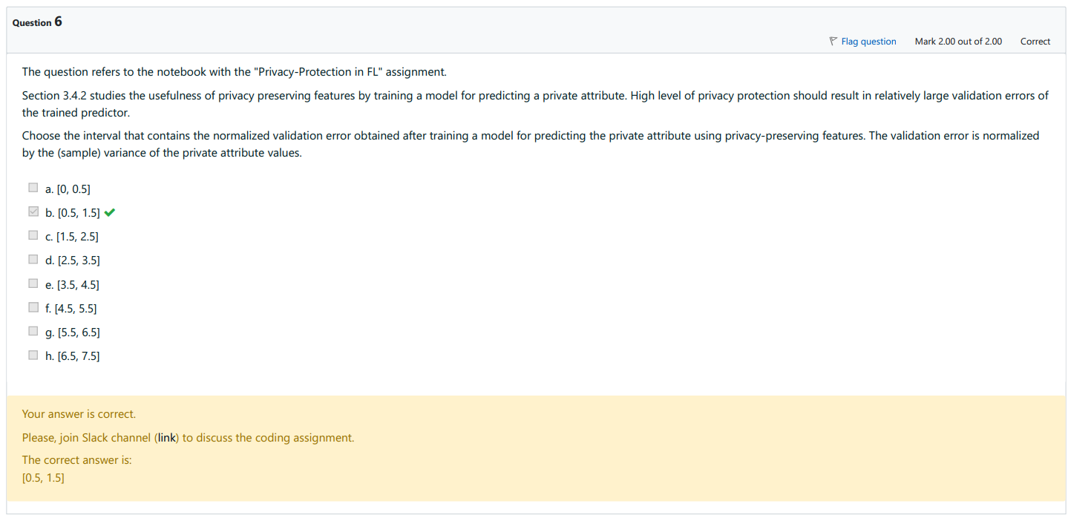

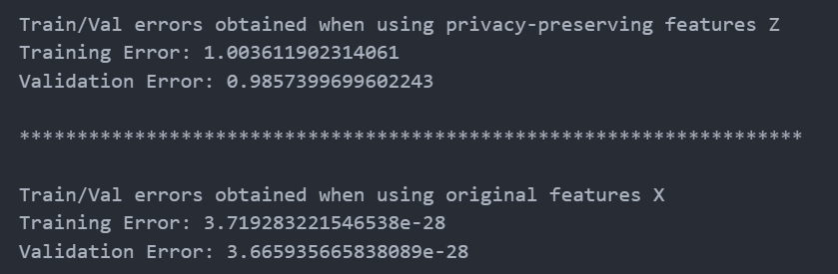

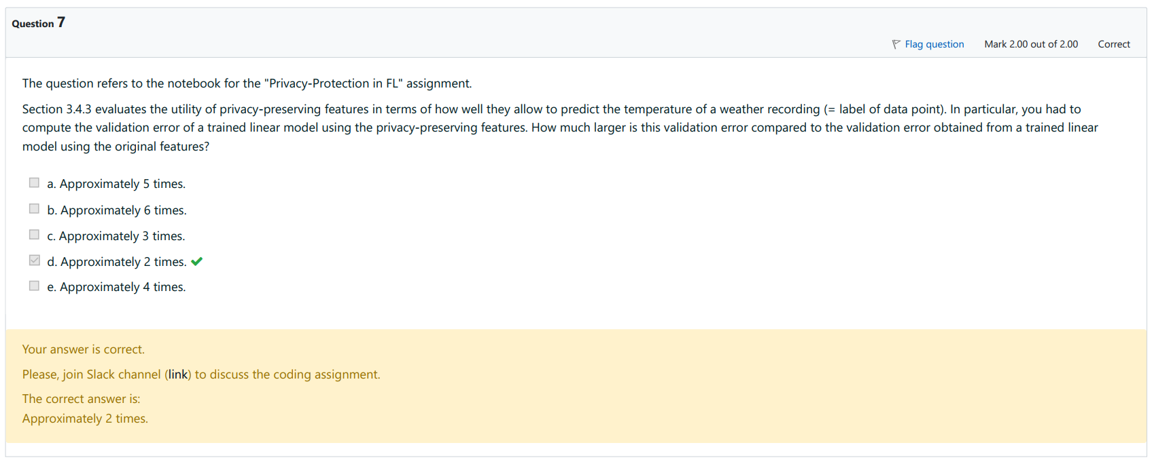

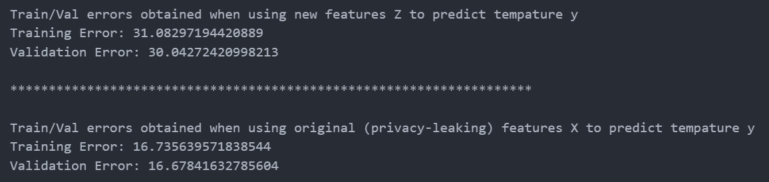

## 9. Data poisoning in FL

